***Melia Natural Products***

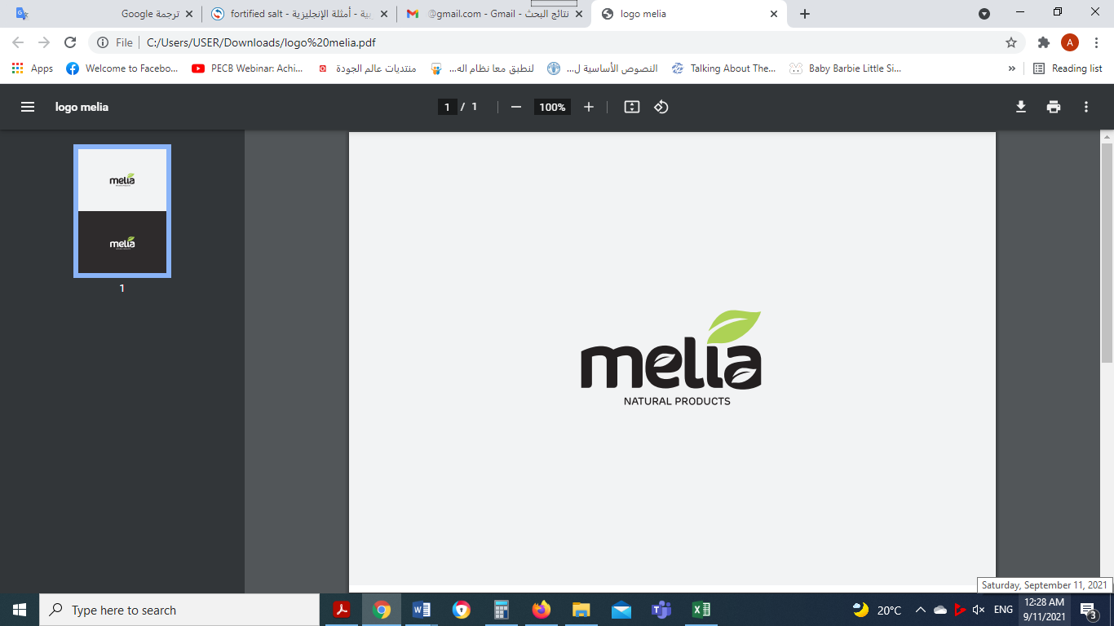

***Business Plan***

OBADER Project

June 2021

Contents

[Melia for natural products 4](#_Toc82214860)

[Overview 4](#_Toc82214861)

[The suggested Organization structure and main roles 4](#_Toc82214862)

[Melia's Products 5](#_Toc82214863)

[Target Market 8](#_Toc82214864)

[Moringa Global market 8](#_Toc82214865)

[Moringa local market 9](#_Toc82214866)

[Herbs Global Market 9](#_Toc82214867)

[Herbs Local Market 9](#_Toc82214868)

[Expected Market and Competition 11](#_Toc82214869)

[Business Plan 14](#_Toc82214870)

[Melia targeted markets 14](#_Toc82214871)

[Marketing 14](#_Toc82214872)

[Sales 19](#_Toc82214873)

[Annual growth production after maturity of Moring 1%. 20](#_Toc82214874)

[Moringa Farm Operations 21](#_Toc82214875)

[Production Unit Operations 24](#_Toc82214876)

[Machines & Equipment 26](#_Toc82214877)

[Detailed business plan schedule 30](#_Toc82214878)

[Feasibility study 35](#_Toc82214879)

[1- Expected sales (Quantities Kg) 35](#_Toc82214880)

[2- Purchase and sale prices 37](#_Toc82214881)

[3- Expected Sales (NIS) 38](#_Toc82214882)

[4- Expected raw material cost (NIS) 39](#_Toc82214883)

[5-Melia cost centers 40](#_Toc82214884)

[5-1 Farm cost center 40](#_Toc82214885)

[5-2- Production unit center 43](#_Toc82214886)

[Project Performance 47](#_Toc82214887)

[Future Development 47](#_Toc82214888)

[Annex A: Analysis of external and internal markets 48](#_Toc82214889)

[Moringa Global market 48](#_Toc82214890)

[Moringa local market 53](#_Toc82214891)

[Herbs Global Market 53](#_Toc82214892)

[Herbs Local Market 55](#_Toc82214893)

[Expected Market and Competition 62](#_Toc82214894)

# Melia for natural products

## Overview

Melia Natural Products is a Palestinian private limited company based in Palestine, Jericho.

The company has been established in 2020 and it is considered a pioneering agricultural and industrial feminist project that aims to benefit from aromatic and medicinal plants and herbs by manufacturing personal care products and nutritional supplements.

Maleeha Nassar Abu Zaid worked for more than ten years as a beekeeper producing honey and other beehive products such as Wax, Propolis and Venom. Her main idea behind this project was to manufacture natural organic beehive products but her idea expanded and developed to include aromatic and medicinal plants and herbs after enrolling in a 23-day course that took place in China “Women’s Leadership and Management" where she has been introduced to many entrepreneurial innovations and projects that focused on the manufacturing of aromatic and medicinal herbs and plants. This experience encouraged Maleeha to launch this project, as she believes it is related to her experience in beekeeping and honey production and other beehive products. Moreover, Maleeha sees a great potential in this business for the increased interest in natural and organic products which reflect good environmental effects when using natural or organic fertilizers in farming instead of chemicals that affect the environment, bedsides to biodiversity of many agricultural products.

## The suggested Organization structure and main roles

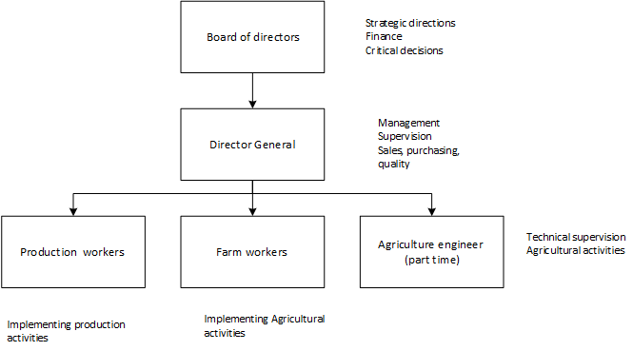

Figure 1: Melia structure

## Melia's Products

**First stage products**

Melia will produce the following product because of available quantities of herbs, readiness of machines, and well-designed labeling and packaging materials.

Note: the following photos are used for illustration purposes.

|  |  |
| --- | --- |
| 1. Paper Box Round Shape of **leaves and grinded** leaves  * Moringa * Thyme (original, Moses, Persian) * Ixiolirion * Sagebrush * Rosemary * turmeric (Curcumin) * Cloves * Ginger * Anise * Mentha (mint) * Basil * Sage * Fennel (Foeniculum vulgare) * Sumac * Teucrium polium * Inula * Wormwood * Peganum * Capparis spinosa * Ferula hermonis * Laurocerasus * Chamomile * Petroselinum (parsley)   volume: 100 ml |  |
|  |  |

**Second stage products**

Melia will produce the following products after getting permission of ministry of health and approval to produce capsules, after getting well-designed machine for oil extraction, and after getting available supplement of honey.

|  |  |  |
| --- | --- | --- |
| 1. **Capsules of grinded herbs**  * Thyme * Saffron * Chamomile * Sage * turmeric (Curcumin) with black pepper * Moringa leaves powder   Food Grade Silica Gel Packets  capacity 50 /100 capsules |  | nourish &amp; glow Organic Moringa Capsules Price in India - Buy nourish &amp; glow  Organic Moringa Capsules online at Flipkart.comThyme Organic Thymus Vulgaris Capsules 90 X 500mg – NutriHerbs |
| 1. **Herbs oil**  * Thyme (original, Moses, Persian) * Ixiolirion * Sage * Rosemary * Mentha (mint) * Basil * Lavender * Chamomile * Moringa * Petroselinum (parsley) * Castor   volume 50 ml |  | Moringa Oil Uses and BenefitsMoringa Oil 100% Pure Virgin Cold Pressed l, Anti-Aging, 4 fl.oz. USDA  Organic 657258674035 | eBay |
| 1. **Honey products** (glass bottles, 50 gr to 1 kg) |  |  |

# Target Market

## Moringa Global market

* **MORINGA INGREDIENTS MARKET INDUSTRY TRENDS**

According to Market Intelligence Report[[1]](#footnote-1): Moringa, the market size in 2018 was 5.5 billion (USD), and Compound annual growth rate (CAGR)[[2]](#footnote-2) will be 8.9% forecast period 2019 to 2025, so the value of market size will be 10 billion (USD) in 2025.

Increasing demand for food supplements owing to rising awareness about nutrition, growing geriatric population, hectic lifestyle, and rising disposable income.

Growing awareness regarding the medicinal benefits of Moringa-based products is projected to propel industry growth.

Global dietary supplements market surpassed USD 125 billion in 2018. In dietary supplements, moringa is used **as an ingredient** due to presence of a large number of essential nutrients that help in improving health.

* **GROWTH DRIVERS**
* North America: Increasing demand for dietary supplements
* Europe: Growing demand for Health / organic products
* Asia Pacific: Growing demand for plant-based cosmetic products
* Moringa tea market size from online distribution channel may register gains close to 7.5% during the forecast time period. Growing per-capita disposable income along with increasing penetration of online purchase in the U.S, India, China, Germany, and UK may contribute towards segment growth.
* **Moringa leaf powder**

The main markets for dietary supplements are the US, followed by Western Europe and Japan, all with an affluent middle class willing to invest in alternative health and food products.

* **Moringa Oil**

Producers of moringa were able to get around US $15.45/lb for their moringa oil (sourced from local smallholder farmers) on the international market (source: http://moringaconnect.com/moringa-oil/).

## Moringa local market

Some farmers planted the moringa tree in Palestine in separate areas in the West Bank and Gaza Strip, but in small quantities and there are no official or known statistics about the quantities that have been planted, as these projects are considered experimental projects.

The farmers market moringa products such as ground leaves in the West Bank and Gaza Strip, but in herbalist shops and some pharmacies.

The local marketing of Moringa products needs a great effort in introducing consumers to the importance of Moringa and its products and its nutritional and medicinal benefits.

## Herbs Global Market

According to global market studies in herbs industry such as Herbal Supplements Market[[3]](#footnote-3), the  herbal supplements market, in terms of value, is projected to reach around USD 86.74 Billion by 2022, at a CAGR of 6.8% from 2016 to 2022. The growing awareness for preventive healthcare methods is the major driving factor of this market, while according to Herbal Medicine Market Global Sales[[4]](#footnote-4), the global herbal medicine market size was estimated to be US$ 83 billion in 2019 and is expected to reach US$ 550 billion by 2030 at a CAGR 18.9% through 2030.

The Latin American and Asia-Pacific regions are potential markets for herbal supplements in the pharmaceutical industry due to increased efficiency in research & development initiatives taken by manufacturers, as well as consumer preference toward herbal medications.

Turkish herbal market is 2.5% of the global market according to Arkan Armish, Director of Livestock and Plant Resources.[[5]](#footnote-5) Which reflect that Turkish market is potential for Melia to market in.

## Herbs Local Market

Since ancient times, the people of Palestine have used a wide list of plants in human and veterinary medicine; Including: Thyme: It is used as food and as a treatment for respiratory diseases.

Today, many citizens have tended to grow these plants for commercial use. Among the most important governorates that are famous for the cultivation of medicinal plants today in Palestine[[6]](#footnote-6) are:

| # | Region | The area in acres (dunums) | |
| --- | --- | --- | --- |
| Protected/ irrigated | Exposed/ irrigated |
| 1 | Tubas Governorate | 490 | 300 |
| 2 | Jenin Governorate | 86 | 430 |
| 3 | Jericho and the Jordan Valley | 300 | 39 |
| 4 | Tulkarm Governorate | 25 | 1,000 |
| 5 | Qalqilya Governorate | 1,100 | 200 |
| 6 | Nablus Governorate | 350 | 0 |
| 7 | Hebron Governorate | 101 | 5,900 |
|  | Sum | 2,452 | 7,869 |

Among the most important countries importing medicinal plants from Palestine are:

1. United States of America
2. United Arab Emirates (UAE)
3. Russia
4. Europe Union

## Expected Market and Competition

**1- Moringa products; the potential markets are:**

1. **EU Countries and UK**

* There is a growing market for nutritional supplements in Europe. According to the [Fortune Business Insights](https://www.globenewswire.com/news-release/2020/01/09/1968257/0/en/Europe-Dietary-Supplements-Market-Size-to-Reach-USD-20-89-Billion-by-2026-High-Demand-for-Clean-label-Products-to-Boost-Growth-Fortune-Business-Insights.html), the European dietary supplements market is projected to reach USD 20.9 billion by 2026. It is forecast that the market will grow at a compound annual growth rate of 4.9 percent between 2019 and 2026.
* In European markets, the main competitors are big and medium Indian companies. India[[7]](#footnote-7) is the leading producer of moringa drumsticks in the world with a production of 2.2 million tons of tender fruits annually, according to Agri Exchange.
* Moringa is also produced in Asia, Africa and Latin America in countries such as the Philippines and Bangladesh, Pakistan, South Africa, Ghana, Mozambique, Kenya, Zambia, Pakistan, Brazil and Peru.
* Prices of Moringa products in Germany and Franc as samples of EU countries

|  |  |  |
| --- | --- | --- |
| Product | Price of 1 kg (USD) | |
| Germany | France |
| [Dried Moringa Leaves](https://www.indiamart.com/proddetail/dried-moringa-leaves-8613480097.html) | 53.71- 83.55 | 62.69 |
| [Moringa Leaves](https://www.indiamart.com/proddetail/dried-moringa-leaves-8613480097.html) powder | 38.20- 57.29 | 68.75 |
| Organic Moringa Leaf Powder | 107.42 | 119.36- 143.23 |
| Moringa seeds | 107.42-163.52 |  |
| Moringa oil | 190.98- 208.88 | 189 |
| Herbal Moringa capsules (100 capsules) | 14.32- 15.28 |  |
| [Organic Moringa Capsules](https://www.amazon.de/-/en/Organic-Moringa-Capsules-Laboratory-Ingredients/dp/B010BW5P10/ref=pd_lpo_121_t_0/262-2796707-4751248?_encoding=UTF8&pd_rd_i=B010BW5P10&pd_rd_r=4413c015-2a93-4b5d-aaf7-adf6301e2505&pd_rd_w=OrUs7&pd_rd_wg=nW4HT&pf_rd_p=09ea9b56-9040-40db-aab6-4478ca27bcd8&pf_rd_r=FN5FYAM8XFB2XG7EXMV8&psc=1&refRID=FN5FYAM8XFB2XG7EXMV8) (100 capsules) | 16.71- 20.29 |  |

**Note that organic product price is 125% to 224.9 %of conventional products**

1. **North America, USA, and Canada**

* The North American market for moringa products was valued at US$ 1062.2 million in 2018 and is expected to grow at a CAGR of 8.8% during 2019-2027 to reach US$ 2248.2 million by 2027.
* The North American market for moringa products is still underdeveloped. Only an acute portion of North American consumers knows about moringa and its attributed advantages. Therefore, awareness regarding the advantages and benefits of moringa is necessary among a significantly large portion of the population in the region.
* Moringa Malawi, Kuli Kuli Inc., Organic India Pvt. Ltd., Ancient Greenfields, Green Virgin Products LLC, and Earth Expo Company are among a few players present in the North American moringa products market.

1. **Turkey**

|  |  |
| --- | --- |
| Product | Price of 1 kg (USD) |
| Turkey |
| [Dried Moringa Leaves](https://www.indiamart.com/proddetail/dried-moringa-leaves-8613480097.html) | 50-52 |
| [Moringa Leaves](https://www.indiamart.com/proddetail/dried-moringa-leaves-8613480097.html) powder | 38 |
| Organic Moringa Leaf Powder | 52 |
| Moringa seeds | 97.54 |
| Moringa oil | 35.05- 52.57 |
| Herbal Moringa capsules (100 capsules) | 17.5 |
| [Organic Moringa Capsules](https://www.amazon.de/-/en/Organic-Moringa-Capsules-Laboratory-Ingredients/dp/B010BW5P10/ref=pd_lpo_121_t_0/262-2796707-4751248?_encoding=UTF8&pd_rd_i=B010BW5P10&pd_rd_r=4413c015-2a93-4b5d-aaf7-adf6301e2505&pd_rd_w=OrUs7&pd_rd_wg=nW4HT&pf_rd_p=09ea9b56-9040-40db-aab6-4478ca27bcd8&pf_rd_r=FN5FYAM8XFB2XG7EXMV8&psc=1&refRID=FN5FYAM8XFB2XG7EXMV8) (100 capsules) | 24 |

**Moringa is known in turkia**

**https://foodstrend.com/moringa-plant-10-miraculous-benefits/**

* The moringa plant, which has made its name known in Turkey in recent years, is now easily available within the borders of the country.
* Moringa plant, which can be grown in Gaziantep Nurdağı in Turkey, has been a useful plant produced by female producers who started in 2017 in very small scale project to produce 30,000 kg of Moringa leaves . The project is to make soap and shampoo from the produced moringa plant[[8]](#footnote-8).
* In general, turkey imports maoringa from India, Ethiopia, Indonesia, China, Ghana and others, such as companies: TAMIL TRADERS, MALALIA AGRI PRODUCTS PLC, HERMS SUPPLIER.
* Main Exporter in Turkey is ERSAG INDUSTRIAL AND CHEMICAL CLEANING PRODUCTS [[9]](#footnote-9):

**Arabic Countries**

1. **Egypt**

* Egypt shares 4.54% export globally, and it is ranked fourth country in the world. The export value of Egypt was USD 138.42 Million in 2020.

1. **Morocco**

* Morocco shares 4.54% export globally, and it is ranked tenth country in the world. The export value of Morocco was USD 43.95 Million, in 2020

1. **Arabic gulf countries**

* Some farmers planted Moringa especially in Arabia Saudi, but the quantities of produced Moringa are not significant.
* These countries import Moringa from India mainly (USD 4 /kg paper moringa, USD 25/ Kg oil).
* Moringa products are consumed in these countries, and consumers are aware of its benefits in medical and nutrition.
* Prices of Moringa products ,the following tables shows prices in selected countries.

|  |  |  |  |  |  |
| --- | --- | --- | --- | --- | --- |
| Product | Price of 1 kg (USD) | | | | |
| Arabia Saudi | Emirates | Egypt | Algeria | Morocco |
| [Dried Moringa Leaves](https://www.indiamart.com/proddetail/dried-moringa-leaves-8613480097.html) |  |  | 15.94 | 11.19 | 41.60 |
| [Moringa Leaves](https://www.indiamart.com/proddetail/dried-moringa-leaves-8613480097.html) powder | 96.00 | 61.25- 74.87 | 19.13 | 10.07 | 51.72 |
| Organic  [Moringa Leaves](https://www.indiamart.com/proddetail/dried-moringa-leaves-8613480097.html) powder | 176.00 | 88.48 |  |  |  |
| Moringa seeds |  |  | 28.69 |  | 28.11 |
| Moringa seeds powder |  |  | 44.64 |  |  |
| Moringa oil | 397.60- 517.34 | 163.35- 179.68 | 52.29- 59.30 |  |  |
| Herbal Moringa capsules (100 capsules) | 39.20 | 12.25 |  | 13.42 | 0.63 |

# Business Plan

## Melia targeted markets

Melia Co. will market its product initially in local market for the first two years, and later in external markets. As shown in market studies, the potential markets are in the following points:

Melia will market its product in the following targeted markets for sited above market analysis;

**1- Local market**

* Melia will market its products in local market, specially moringa products; due to weak competition, high valuable products, low production cost, while for herbs; the market is potential due to diversity of herbal products, availability sources of herbs, attractive products, and consumers aware of benefits of herbs.
* Melia will push a good effort to increase consumers aware of benefits of moringa through activities will sited later in the next section.

**2- Arabic gulf countries and Turkey**

* Melia will market its products in - Arabic gulf countries and turkey markets, specially moringa products; due to lack of produced quantities in that countries, high valuable products, low production cost, besides to these countries are aware of its benefits in medical and nutrition.

**3- EU Countries and UK, North America, USA, and Canada**

* Melia can market Moringa leaves, powder, Moringa tee bags, and Moringa oil, in either conventional or organic production. For the first 3 years of this project, Melia will market as conventional or conversion to organic due to technical in organic rules of EU commission, but it is preferred to start registering in organic production certification (EU organic production) because of profitability and marketability of organic Moringa, i.e the price of organic Moringa is twice price of conventional Moringa. Besides, to organic certification, Melia can starts Global GAP certification.

## Marketing

According to pervious data, business requirements to achieve sustainability of Melia Co.; the company will perform the flowing activities:

1. Register trademark of products according to Ministry of National Economy. Melia trademark will reflect naturalist, nutritional, and medical benefits, quality, and proudness of products.
2. Brand Awareness; refers to keeping the qualities and feelings associated with the product top-of-mind for customers. Where Brand recognition is the extent to which a consumer can correctly identify your brand based on visual indicators such as logo and colors. Products and services that maintain a high level of brand awareness are likely to generate more sales. Many means to increase brand awareness such as: create a custom [hashtag for Instagram,](https://www.wordstream.com/blog/ws/2020/08/20/daily-hashtags) participate in or sponsor local events, post regularly to social media using the brand voice, run display ads on the [Google Display Network](https://www.wordstream.com/blog/ws/2014/11/18/google-display-network-tips), Use eye-catching visuals, advertising in the right places, and developing a distinct voice in the content, LinkedIn publishing, social focus, social media contests, car wraps, infographics, or paid social advertising;
3. Design Product Labeling: Product labeling is the act of writing and displaying information about a product's packaging. The product labels show important details which customers must know; there are product details that are legally required to show on the label. In some cases, these details are even required to be placed on a label's specific area. The details depend on the type of the product. The label contains at least Product Name, Series Name, Packaging Size, Company Contact Information, and Barcode.
4. Design marketing materials with specialist graphic designer. To attract probable customer and consumers;

* Business Cards: cards present Melia and its personnel to public when connecting with them, including name, position, and email address. Keep a list of referral partners and give them enough cards. Use a version of your business card as a sticker for envelopes, Include in invoices and correspondence and bags.
* Outdoor Signs: If you have an outdoor sign, make sure that it is in good shape; lights working, letters and writing visible from a distance. Keep outdoor signs simple and eye-catching, and add point-of-purchase signs to drive customers to featured products.
* Product brochures: A product brochure is a brochure used to promote or detail the features of a product.
* Product support manuals: Product support manuals detail the use of a product.
* Advertising materials: Advertising materials are materials aiming to attract public attention to a product. Advertising materials come in many forms including print, television, via the internet, radio and billboards.
* Direct mail pieces: Direct mail pieces are advertising circulars or other printed matter sent directly through the mail to a specific demographic group, geographical area, and customer base or target market.
* Electronically: Electronic marketing material is produced by electronic means. A new product may be advertised by a virtual tour on the web.
* Multimedia: Multimedia Marketing material uses a combination of several media, such as movies, slides, music, and lighting.
* Web Sites: A web site is a set of interconnected Web pages, usually including a home page, prepared and maintained as a collection of information by a person, group, or organization.

1. Design Interactive Websites with specialist IT Company, and utilize social media to market the products and connect with potential customers.

Interactive websites are exactly what they sound like: websites that allow the user to interact with the content in some way. This may mean incorporating a contact form, which a user fills out and sends to the site owner. Alternatively, it could involve a form that allows a user to submit comments or feedback.

They may also provide virtual tours of a property or animated display of weather patterns. The point of interactive sites is to make the user's experience as engaging as possible. They are intentionally designed to maximize user interaction. Maximized user interaction plays a huge role in conversion rates and more.

Melia will design interactive web site in cooperation with specialist IT Company for the following objectives:

* Obtain Valuable Data; Effective data analytics can ensure you make the most of marketing campaigns, and enable Melia to get data of potential customers to connect.
* Connect with Customers; Melia will show the customers intent to interact with them. Establishing this connection with customers is essential to building a relationship from the start. It also sets the standard for personalized marketing efforts.
* Personalized marketing is much more effective than general campaigns. Customers like engaging with brands in a transparent, intimate way. They will be more likely to follow a brand that is interested in them. They will avoid brands that just want to make a sales pitch.
* Get Customer Commitment; Interactive websites, however, can get the commitment you need from passing visitors. When a visitor engages with a website, by either providing profile information or posting content, they are more likely to return to that website later on.
* Backlink the Right Way; When a customer has a positive interactive experience with Melia's website, they'll be more likely to share the site across social media platforms and more. These shares are valuable backlinks.
* Are Noticed; the more visible you are as a brand, the higher your chances are for growing your customer base.
* Develop Purposeful Content; Interactive websites are known for their rich, engaging content. Content is essential, both on your website and throughout marketing campaigns. It is important to have relevant, useful, and authoritative content. Better content can also help you achieve a higher Google ranking.
* Social media; Social networking sites such as Instagram, LinkedIn, Tiktok, Twitter and Facebook are essential for maintaining a competitive edge. Companies that do not have active social media accounts risk missing out on numerous marketing opportunities.

Some of benefits of social media as marketing tool:

* Improve Responsiveness
* Competition
* Effective Marketing
* Find Customers
* Affordability
* Database
* Social Environment
* Informative
* Online Presence
* Communication and Branding

1. Participating in local and external Marketing Exhibitions

Exhibition venues are an important tool in promoting exhibitors’ destination image. Venues act as a communicative environment for both visitors and exhibitors.

Locally, there are some of Exhibitions such as National exhibitions organized by chamber of commerce, Hebron Exhibition Center, Pal food Exhibition, while externally, Pal trade organize participation of Palestinian companies.

Some of benefits of exhibitions as marketing tool:

* Face-to-face interaction
* Exhibitions help build brand proximity
* Better platform than irksome cold calling
* Exhibition visitors are in the right mind frame during the show
* Exhibitions help you know your Competitors Well

1. Sponsor of social or economic events (for second stage; after 2 years)

Sponsorships are the financial or in-kind support of activities. Businesses often sponsor events, [trade shows](https://www.thebalancesmb.com/before-you-attend-that-trade-show-2947181), groups, or [charity causes](https://www.thebalancesmb.com/cause-marketing-4161489) to reach specific business goals and increase their competitive advantage.

Though sponsorship is a form of marketing, it is different from [advertising](https://www.thebalancesmb.com/advertising-2947182), which attempts to persuade customers to make purchases by sharing specific messages about a product or company.

Sponsorships, on the other hand, don't directly promote your company or products. Instead, your company pays to support a specific event that your customers care about. Your business is then associated with the event by customers, attendees, and the media.

Promotional opportunities at trade shows, charity events, or business functions include sponsorships of pressrooms, an international lounge, a speaker or VIP room, an awards reception, educational programs, banners, badge holders, audiovisual equipment, display computers, shuttle buses, tote bags, or other branded swag.

Local causes such as sports teams or charity drives offer more limited places for your branding and products, but they allow you to reach a specific local audience.

Some of benefits of Sponsor of social or economic events as marketing tool:

* Shape consumer attitudes
* Build brand awareness
* Drive sales
* Increase reach
* Generate media exposure
* Differentiate yourself from competitors
* Take on a "corporate citizen" role
* Generate new leads
* Enhance business, consumer, and VIP relationships

1. Advertising Campaigns

A marketing campaign is a strategic marketing effort aimed at promoting a specific endeavor or goal on behalf of a company, brand or individual. Marketing campaigns are designed to get consumers' attention in several ways, such as television, print advertising, social media and email marketing. The ultimate goal of a marketing campaign is typically to increase awareness of an organization and bring in new customers.

The following are several types of marketing campaigns you can use to achieve various marketing goals within your organization:

* Traditional media campaign
* Seasonal push campaign
* Product launch campaign
* Brand awareness campaign
* Rebranding campaign
* Brand launch campaign
* Contest marketing campaign
* Email marketing campaign
* Payed- google advertisement

1. Connecting with women associations

Melia will connect and visit woman associations. The purpose of these visits is to present the products face to face, besides to get feedback about the products. Women associations are concerned to enhance imitative business owned by women.

## Sales

Melia project the annual sales according to the flowing considerations:

1. Herbs other than Moringa with global annual growth 9%, the base year is 2021, projected sales for all herbs depend on benchmark with small to medium business.
2. Moringa leaves and related products sales [[10]](#footnote-10) with 90% of projected produced quantities and nature of Moringa trees, 30,000 m2, (30,000 m2 x 224 kg leaves/1000 m2 = 6,720 kg/ year in maturity of trees (starts after 1 year from planting))
3. Moringa oil, which is extracted from seeds. Every 1000 m2 is expected to produce 120 kg seeds, and oil extraction ratio is 0.125 kg oil/1 kg seeds (without bark). So expected produced oil 30,000 m2 x 120 kg seeds/1000 m2 = 3,600 kg seeds/ year in maturity of trees, extracted oil= 0.125 kg oil/1 kg seeds X 600 kg seeds/ year= 450 kg oil.
4. The following table shows projected sales (by Weight) for each product.

**Projected sales by Weight (Kg)**

|  |  |  |  |  |  |  |  |  |  |  |
| --- | --- | --- | --- | --- | --- | --- | --- | --- | --- | --- |
| Year | **2021** | **2022** | **2023** | **2024** | **2025** | **2026** | **2027** | **2028** | **2029** | **2030** |
| Moringa kg | 3,360 \* | 6,720 \* | 8,960 \* | 9,139 | 9,322 | 9,508 | 9,699 | 9,893 | 10,090 | 10,292 |
| moringa oil liter | 281 | 563 | 750 | 758 | 765 | 773 | 780 | 788 | 796 | 804 |
| Thyme (original, Moses, Persian) kg | 1,400 | 1,526 | 1,663 | 1,813 | 1,976 | 2,154 | 2,348 | 2,559 | 2,790 | 3,041 |
| Sagebrush | 500 | 545 | 594 | 648 | 706 | 769 | 839 | 914 | 996 | 1,086 |
| Rosemary | 200 | 218 | 238 | 259 | 282 | 308 | 335 | 366 | 399 | 434 |
| turmeric (Curcumin) | 200 | 218 | 238 | 259 | 282 | 308 | 335 | 366 | 399 | 434 |
| Sumac | 500 | 545 | 594 | 648 | 706 | 769 | 839 | 914 | 996 | 1,086 |
| Black pepper | 200 | 218 | 238 | 259 | 282 | 308 | 335 | 366 | 399 | 434 |
| Cloves | 100 | 109 | 119 | 130 | 141 | 154 | 168 | 183 | 199 | 217 |
| Ginger | 200 | 218 | 238 | 259 | 282 | 308 | 335 | 366 | 399 | 434 |
| Anise | 200 | 218 | 238 | 259 | 282 | 308 | 335 | 366 | 399 | 434 |
| Mentha (mint) | 500 | 545 | 594 | 648 | 706 | 769 | 839 | 914 | 996 | 1,086 |
| Basil | 200 | 218 | 238 | 259 | 282 | 308 | 335 | 366 | 399 | 434 |
| Laurocerasus | 100 | 109 | 119 | 130 | 141 | 154 | 168 | 183 | 199 | 217 |
| Chamomile | 100 | 109 | 119 | 130 | 141 | 154 | 168 | 183 | 199 | 217 |
| Petroselinum (parsley) | 100 | 109 | 119 | 130 | 141 | 154 | 168 | 183 | 199 | 217 |
| herbs oil | - | 75 | 82 | 89 | 97 | 106 | 115 | 126 | 137 | 149 |

* Assumptions: Melia planted in 2020 ,2021 and will plant in 2022: 15,000 m2,

|  |  |  |  |
| --- | --- | --- | --- |
| year | 2020 | 2021 | 2022 |
| Moringa planting area (m2) | 15,000 | 30,000 | 40,000 |
| expected produced moringa leave (224 kg/ 1000m2) | 3,360 | 6,720 | 8,960 |
| expected produced moringa oil from seeds( 150 kg seeds/ 1000 m2, and .125 kg oil / 1 kg seeds= 18.75 kg extracted oil / 1000 m2) | 281 | 563 | 750 |

## Annual growth production after maturity of Moring 1%.

## Moringa Farm Operations

1. Planting Moringa trees[[11]](#footnote-11)

* **Planting instructions**

Moringa trees grow best from seeds, but they can be grown from cuttings. To grow from seed outside, prepare a seedbed that drains well, and is in a sunny location. Moringa trees need at least six hours of direct sunlight per day and will tolerate more. Water the seed bed thoroughly, but make sure that the water drains away. After the initial planting, water near the seedling (but do not water it directly).

You can plant a cutting vertically or horizontally. The base of the cutting should be about as big around as a thumb. To plant vertically, cut a straight twig with several buds near the bottom end of it. Prepare a bed, as if you were going to plant a seed. Using a different stick, drill a narrow hole into the loose soil, then insert the cutting. To plant horizontally, prepare a long bed. Cut a limb piece that has several bud nodes on it. Place it in the prepared bed.

Moringa trees are not fond of being transplanted because they have an exceptionally long tap root. This taproot is one reason a moringa tree is resistant to drought. With this in mind, they will do best in a tall planter that has excellent drainage holes at the bottom. Water lightly, keeping the soil on the dry side especially after the seed has sprouted or the cutting has put up shoots. If the leaves begin to yellow, your moringa has probably been over watered.

* **Watering and nutrients**

Moringa trees require very little water and prefer a sunny space that is well-drained. When it comes to nutrients, they will do nicely on a vegetable compost applied as a top-dressing.

* **Pollination**

It is a good idea to have several Moringa plants if you would like for them to produce seed. They are dichogamous, meaning that the stamens and pistils will mature at different times. Such trees do better if they are cross-pollinated with other trees. They are attractive to bees and similar pollinating insects. However, pollination is not essential if you are primarily growing them for the leaves.

* **Pruning**

Moringa trees grow exceptionally fast and can handle heavy pruning. In fact, pruning your moringa tree back almost to a stump at the end of the growing season will encourage it to put out several branches. This will keep it bushy and short enough for easy harvesting.

* **Pests, diseases, and animals**

The leaves of the moringa tree are spicy (like horseradish). This tanginess is appreciated add a pleasant kick to blander foods, but insects and nibbling mammals tend to dislike it.

1. Setup watering network and water supply

Drip irrigation: A type of localized irrigation in which drops of water are delivered at or near the root of plants. In this type of irrigation, evaporation and runoff are minimized. It is currently the most popular method used on these types of permanent crops.

The distance between Moringa trees is 1.5 m, and every 1000 m2 contains 430 trees.

1. Contracting with Jericho cooperative for reclamation 15,000 m2 and planting

Land reclamation, the process of improving lands to make them suitable for a more intensive use. Melia will contract with the cooperative for reclaim 15,000 m2 to increase quantities of Moringa leaves and seeds, which are required in production.

Setup Moringa washing unit Melia will wash and clean moringa leves manually by using baskets and pots, but if the electricity is available in the farm, but in case of solar energy projects funded by green economy or others NGO funded programs, Melia will purchase washing machine and water storage tanks (capacity 3 m3). The washing machine Air bubbles leafy vegetable washing machine or re-cut washed salad root leaf vegetable dryer machine as shown in figures below.

|  |  |
| --- | --- |
| Figure **8: Air** bubbles leafy vegetable washing machine | Figure **9:** re-cut washed salad root leaf vegetable dryer machine |

1. Design and build solar dryer unit

The objective of this dryer is to dry the leaves after washing. Drying method is solar drying.

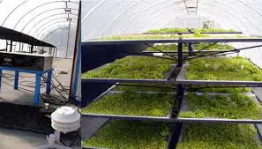

Figure 10: Solar dryer

1. Solar energy unit (in case of solar energy projects funded by green economy or others NGO funded programs)

Melia will contract with solar energy projects to provide a solar unit to operate lighting, pumps, solar dryer unit (fans), and Moringa washing unit.

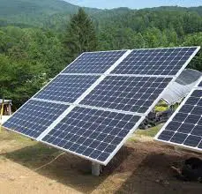

Figure 11: 6- Solar energy unit

1. Contracting with Moringa farmers

Melia will evaluate actual needs of Moringa and Thyme, in case of lack of harvested Moringa and need to fulfill Moringa demand as products, Melia will contract with Moringa Farmers to compensate the occurrence of any shortage.

1. Organic Moringa certification, NOP, Global GAP

Organic Agriculture is a production system that sustains the health of soils, ecosystems, and people. It relies on ecological processes, biodiversity and cycles adapted to local conditions, rather than the use of inputs with adverse effects. Organic Agriculture combines tradition, innovation, and science to benefit the shared environment and promote fair relationships and good quality of life for all involved.

Organic certification, accredit certification body will assess the farms and document according to EU organic regulations. The certification body in Palestine is company of organic agriculture in Palestine (COAP). This certification body can certificate NOP and Global GAP.

NOP is a federal regulatory program that develops and enforces consistent national standards for organically produced agricultural products sold in the United States.

Global GAP Global G.A.P. is a private sector body that sets voluntary standards for the certification of agricultural products around the globe. The aim is to establish one standard for Good Agricultural Practice with different product applications capable of fitting to the whole of global agriculture.

The standard is primarily designed to reassure consumers about how food is produced on the farm by minimizing detrimental environmental impacts of farming operations, reducing the use of chemical inputs and ensuring a responsible approach to worker health and safety as well as animal welfare.

## Production Unit Operations

1. Layout design;

The arrangement of machines and equipment within a factory which includes the layout of departments within the factory site, the layout of machines within the departments and the layout of individual work places. The two principal types of factory layout are [PRODUCT-FOCUSED LAYOUTS](https://financial-dictionary.thefreedictionary.com/product-focused+layout) where a product is routed through the factory on a single path, and [PROCESS-FOCUSED LAYOUTS](https://financial-dictionary.thefreedictionary.com/process-focused+layout) where products may follow a variety of routes through job shops in the factory.

Job shops are typically small manufacturing systems that handle job production, that is, custom or semi-custom manufacturing processes such as small to medium-size customer orders or batch jobs. Job shops machines are aggregated in shops by the nature of [skills](https://en.wikipedia.org/wiki/Skills) and technological [processes](https://en.wikipedia.org/wiki/Process_engineering) involved, each shop therefore may contain different machines, which gives this production system processing flexibility, since jobs are not necessarily constrained to a single machine.

The factory layout has a large part to play in optimizing time, space and overall productivity and has a powerful impact on productivity.

An inefficient layout leads to waste. As a facility expands, it can be difficult to find a place for everything. If workstations are set up illogically, the production line can quickly become muddled and personnel may disrupt other processes in order to complete tasks — lessening the time spent working on the product.

To maximize productivity, the company needs a sound production plan. When assessing how to optimize a facility’s productivity, people, materials, space and equipment must all be considered.

Effective planning hinges on a knowledge of the facility’s key activities. When considering the movement around a factory it is important to optimize the space so that it fits production needs, while making the best use of the available area. This can be achieved by reorganizing the shop floor and redefining the key production areas.

Melia's processes, products routs, process flow charts, spaghetti diagram are analyzed to design the layout of production unit. The design depends on product-focused layout.

1. Machines setup and operating procedure

After design the layout of production unit, machines are kept in allocated places. Melia read Operation manuals of all machines; accordingly, they set up machines and operates.

1. Contracting with suppliers of packaging materials

After designing all products label and package material, Melia will contract with supplier or manufacturer to reduce cost of these materials, to supply on the time, and get better quality and good prices.

1. Outsource contracting- oil extraction

Melia produces oil of Moringa and herbs. The first harvest of moringa will be on October 2021. Melia will extract oil from the seeds at outsource producer, and then evaluate feasibility of purchasing oil extraction machine. Melia will contract before the harvest with the outsource producer to reduce cost, assure quality, and delivery on time

1. Outsource contracting – tea bags

Melia produces Moringa and herbs in tea bags. In first two years of this project, Melia can produce tea pages at outsource producer, and then evaluate feasibility of purchasing tea bag filling machine. Melia will contract with the outsource producer to reduce cost, assure quality, and delivery on time

1. GMP, GDP consultation and preparation and GDP certification

Good Storage and distribution practices; Storage and distribution are important activities in the supply chain management of medical products. Various people and entities are generally responsible for handling, storage and distribution. Products may be subjected to various risks at different stages in the supply chain, i.e. during purchasing, storage, distribution, transportation, repackaging, and relabeling. Further, substandard and falsified products are a real threat to public health and safety. Consequently, it is essential to protect the supply chain against the penetration of such products.

Melia will consult a specialist consultant to develop quality system according to GDSP guidelines as a primary step before get permission to produce capsules, and then the company will be ready for external auditing to get certification.

1. Permission to produce Essential Nutrients or Food Supplements

After GDSP certification, Melia will present all required documents to **Ministry of health** to get approval to produce capsules.

1. Outsource contracting – Moringa and Herbs soap

Melia produces Moringa and herbs soap. In first two years of this project, Melia can produce soap bars at outsource producer, and then evaluate feasibility of purchasing mixer, molds to produce soap bars. Melia will contract with the outsource producer to reduce cost, assure quality, and delivery on time.

1. Outsource contracting- Flour fortified with Moringa

Melia can produce flour fortified with grinded moringa by contracting with local flour producer immediately if it is required, this product is produced in Melia production unit as grinded moringa.

## Machines & Equipment

Melia and in cooperation with Obader project, has issued an Operational Producer kit Manual. The manual contains all machines, setup, operational steps, maintenance, and settings; so for more details, please review the manual.

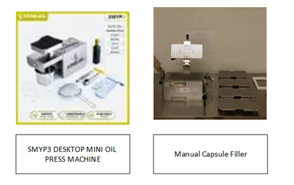

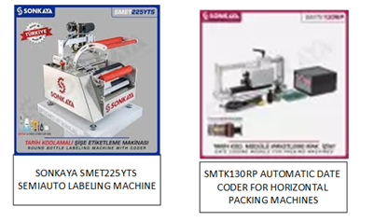

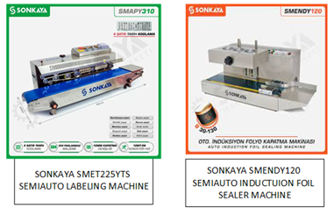

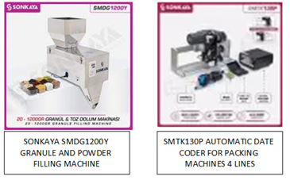

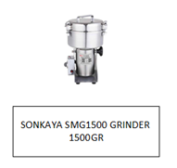

# Detailed business plan schedule

| # | Activity | Responsibility | Period | Justifications |
| --- | --- | --- | --- | --- |
| Marketing | | | | |
| 1 | Register Trademark | Maleeha, lawyer and branding expert.trade mark registration unit, ministry on national economy | September to December 2021 | A trademark is a sign capable of distinguishing the goods or services of one enterprise from those of other enterprises. Trademarks are protected by intellectual property rights., the company shall do the following steps:step 1. Trademark Comprehensive Study: A trademark search report with attorney's analysis and opinion about registration probabilities.step 2. Trademark Registration Request: A trademark attorney will file and process your trademark application before the Trademark Office.The trademark will reflect naturalist, nutritional and medical benefits, quality, and proudness of products. |
| 2 | Design Product Labeling | Maleeha, lawyer and branding expert. | July to December 2021 | The product labels show important details which customers must know. The label shall be compliance with Palestinian standard institute and regulation by governments of potential markets.Product labeling of products may be designed according to the flowing priorities: Moringa (highest priority), Paper Box Round Shape of grinded leaves of other than Moringa, Flat Bottom Printed Aluminum for dried leaves of other than Moringa, Herbs oil, capsules of moringa and other herbs, Honey products (lowest priority) |
| 3 | Design marketing materials | Maleeha and graphic designer | August to December 2021 | To attract probable customer and consumers, comply with legal requirements, direct the consumer how to use products, and have good image of products and company. |
| 4 | Melia Web design |  | June 2022- December 2022 |  |
| 5 | Melia interactive Web design and social media | Maleeha and IT company | March 2023- August 2023 | Melia will design interactive web site in cooperation with specialist IT Company to obtain valuable data,Connect with customers, get customer commitment, get customer commitment, backlink the right way, etc. |
| 6 | Brand / products Awareness | Maleeha and graphic designer | December 2021 to March 2022 | Melia will design and create a custom hashtag for Instagram, LinkedIn publishing, infographics, paid social advertising, besides to visiting coffee shops, super markets, clinic centers and so on. |
| 7 | Participating in local and external Marketing Exhibitions | Maleeha, Chamber of commerce, Pal trade, women associations | Annually, when organizing parties | Externally and locally, Melia can present and market the products in external markets, connect with potential customers, consumers or trade companies. Melia in this case, will develop its website to connect with potential customers also. |
| 8 | Advertising Campaigns | Maleeha | Annually, 2 Campaigns | Marketing campaigns are designed to get consumers' attention in several ways, such as television, print advertising, social media and email marketing. |
| 9 | Connecting with women associations | Maleeha | Annually, 2 visits at least | Melia will connect and visit woman associations. The purpose of these visits is to present the products face to face, besides to get feedback about the products. Women associations are concerned to enhance imitative business owned by women |
| Moringa Farm Operations | | | | |
| 1 | Planting Moringa trees | Maleeha and Agricultural Engineer | March to April 2022 | Melia rents land (area 20,000 m2), at beginning of April 2021, Melia planted 12,000 m2 as 450 trees per 1000 m2, and Melia will complete planting the rest of the land before ending of May 2021. |
| 2 | Setup watering network and water supply | Maleeha and Al-Aowsaj village supervisors | March to April 2022 | Watering Moringa trees needs a water supply and network, in the past, the village faced problem of lack of water, and bought water from outside the village, which was very expensive (NIS 200 per m3). |
| 3 | Reclamation 15,000 m2 and planting | Maleeha, | Contract: January 2022 to March 2022 | At the end of June 2021, the total land area will be 30,000, Melia can harvest from the total area in October 2021. |
|  | Manual washing |  | February to March 2022 |  |
| 4 | Setup Moringa washing unit | Maleeha | April to June 2022 | The washing unit will be ready to work before harvesting Moringa season. Moringa leaves will be washed and dried to remove pesticide residues, dust, etc. |
| 5 | Design and build solar dryer unit | Maleeha, and solar dryer contractor | April to June 2022 | The dryer will be ready to work before harvesting Moringa season. Moringa leaves will be washed and dried to remove pesticide residues, dust, etc. |
| 6 | Solar energy units | Maleeha and solar energy project | March 2022 | To supply electricity to operate solar dryer (fans) and washing unit |
| 7 | Contracting with Moringa farmers | Maleeha and moringa/ thyme farmers | As needed | Melia evaluates actual needs of Moringa and Thyme, in case of lack of harvested Moringa and need to fulfill Moring demand as products, Melia will contract with Moringa Farmer to compensate the shortage. |
| 8 | Organic Moringa certification, NOP, Global GAP | Maleeha, consultant, and certification body | 2024 | Marketing study shows that the price of organic Moringa is about 225% of conventional Moringa in EU countries, USA, and Canada. |
| Production unit operations | | | | |
| 1 | Layout design | Maleeha and Industrial Engineer | May to June 2021 | Melia's processes, products routs, process flow charts, spaghetti diagram will be analyzed to design the layout of production unit. The design depends on product focused layout. The purpose of design optimize productivity, optimize utilizing space, make motion is faster, to reduce production wastes. |
| 2 | Machines setup and operating | Maleeha and Industrial Engineer | May to June 2021 | After design the layout of production unit, machines are kept in allocated places. Melia read Operation manuals of all machines; accordingly, they set up machines and operates. |
| 3 | Contracting with suppliers of packaging materials | Maleeha and packaging supplement company | October to December 2021 | After designing all products label and package material, Melia will contract with supplier or manufacturer to reduce cost of these materials, to supply on the time, and get better quality and good prices. |
| 4 | Outsource contracting- oil extraction | Maleeha and grinding company | September 2022 | Melia produces oil of Moringa and herbs. The first harvest of moringa will be on October 2021. Melia will extract oil from the seeds at outsource producer, and then evaluate feasibility of purchasing oil extraction machine. Melia will contract before the harvest with the outsource producer to reduce cost, assure quality, and delivery on time |
| 5 | Outsource contracting – tea bags | Maleeha and Jericho cooperative | September to December 2022 | In first two years of this project, Melia can produce tea pages at outsource producer, and then evaluate feasibility of purchasing tea bag filling machine. Melia will contract with the outsource producer to reduce cost, assure quality, and delivery on time |
| 6 | Outsource contracting – Flour fortified with Moringa | Maleeha and flour producer | January 2022 | Melia can produce flour fortified with grinded moringa by contracting with local flour producer immediately if it is required, this product is produced in Melia production unit as grinded moringa |
| 7 | GMP, GDP consultation and preparation | Maleeha and consultant | April to June 2022 | Melia will consult a specialist consultant to develop quality system according to GDSP guidelines as a primary step before get permission to produce capsules, and then the company will be ready for external auditing to get certification |
| 8 | GDP certification | Maleeha and certification body or MOH | August to October 2022 |
| 9 | Permission to produce Essential Nutrients: Food or Supplements | Maleeha and MOH | November 2022 | After GDSP certification, Melia will present all required documents to Ministry of health to get approval to produce capsules. |
| 10 | Outsource contracting – Moringa and Herbs soap | Maleeha and soap manufacturer | January 2023 | Melia produces Moringa and herbs soap. In first two years of this project, Melia can produce soap bars at outsource producer, and then evaluate feasibility of purchasing mixer, molds to produce soap bars. Melia will contract with the outsource producer to reduce cost, assure quality, and delivery on time |

# Feasibility study

## 1- Expected sales (Quantities Kg)

* Melia project the annual sales according to the following considerations:

1. Herbs other than Moringa with global annual growth 9%, the base year is 2021, projected sales for all herbs depend on benchmark with small to medium business.
2. Moringa leaves and related products sales [[12]](#footnote-12) with 90% of projected produced quantities and nature of Moringa trees, 30,000 m2, (30,000 m2 x 224 kg leaves/1000 m2 = 6,720 kg/ year in maturity of trees)
3. Moringa oil, which is extracted from seeds. Every 1000 m2 is expected to produce 120 kg seeds, and oil extraction ratio is 0.125 kg oil/1 kg seeds i.e 18.75 Kg oil /1000 m2 (without bark). So expected produced oil 15,000 m2 x 18.75 Kg = 2.81 kg oil/ year in maturity of trees,.
4. The following table shoes projected sales (by Weight) for each product.

| Year | 2021 | 2022 | 2023 | 2024 | 2025 | 2026 | 2027 | 2028 | 2029 | 2030 |
| --- | --- | --- | --- | --- | --- | --- | --- | --- | --- | --- |
| Moringa kg | 3,360 | 6,720 | 8,960 | 9,139 | 9,322 | 9,508 | 9,699 | 9,893 | 10,090 | 10,292 |
| Moringa oil liter | 281 | 563 | 750 | 758 | 765 | 773 | 780 | 788 | 796 | 804 |
| Thyme (original, Moses, Persian) kg | 1,400 | 1,526 | 1,663 | 1,813 | 1,976 | 2,154 | 2,348 | 2,559 | 2,790 | 3,041 |
| Sagebrush | 500 | 545 | 594 | 648 | 706 | 769 | 839 | 914 | 996 | 1,086 |
| Rosemary | 200 | 218 | 238 | 259 | 282 | 308 | 335 | 366 | 399 | 434 |
| turmeric (Curcumin) | 200 | 218 | 238 | 259 | 282 | 308 | 335 | 366 | 399 | 434 |
| Sumac | 500 | 545 | 594 | 648 | 706 | 769 | 839 | 914 | 996 | 1,086 |
| Black pepper | 200 | 218 | 238 | 259 | 282 | 308 | 335 | 366 | 399 | 434 |
| Cloves | 100 | 109 | 119 | 130 | 141 | 154 | 168 | 183 | 199 | 217 |
| Ginger | 200 | 218 | 238 | 259 | 282 | 308 | 335 | 366 | 399 | 434 |
| Anise | 200 | 218 | 238 | 259 | 282 | 308 | 335 | 366 | 399 | 434 |
| Mentha (mint) | 500 | 545 | 594 | 648 | 706 | 769 | 839 | 914 | 996 | 1,086 |
| Basil |  | 218 | 238 | 259 | 282 | 308 | 335 | 366 | 399 | 434 |
| Laurocerasus | 100 | 109 | 119 | 130 | 141 | 154 | 168 | 183 | 199 | 217 |
| Chamomile | 100 | 109 | 119 | 130 | 141 | 154 | 168 | 183 | 199 | 217 |
| Petroselinum (parsley) | 100 | 109 | 119 | 130 | 141 | 154 | 168 | 183 | 199 | 217 |
| herbs oil |  | 75 | 82 | 89 | 97 | 106 | 115 | 126 | 137 | 149 |

## 2- Purchase and sale prices

According to data collected from interviews with herb production companies, the following table reflects actual prices.

Purchase price: Price per Kg of the product that Melia purchases from suppliers.

Sale price: Price per Kg of the product that Melia sales to end customers

|  |  |  |
| --- | --- | --- |
| **Product** | **Purchase price (NIS)** | **Sale price (NIS)** |
| Moringa kg | 100 | 150 |
| Thyme (original, Moses, Persian) kg | 27 | 30 |
| Sagebrush | 25 | 28 |
| Rosemary | 27 | 30 |
| turmeric (Curcumin) | 13 | 16 |
| Sumac | 27 | 30 |
| Black pepper | 22 | 25 |
| Cloves | 35 | 38 |
| Ginger | 15 | 18 |
| Anise | 18 | 21 |
| Mentha (mint) | 18 | 21 |
| Basil | 18 | 21 |
| Laurocerasus | 28 | 31 |
| Chamomile | 27 | 30 |
| Petroselinum (parsley) | 10 | 13 |
| herbs oil | 150 | 170 |
| moringa oil liter |  | 190 |
| moringa seeds | 70 |  |

## 3- Expected Sales (NIS)

To get expected sales (NIS), the expected sales (Quantities Kg) X sale price for the product

| **Year** | **2021** | **2022** | **2023** | **2024** | **2025** | **2026** | **2027** | **2028** | **2029** | **2030** |
| --- | --- | --- | --- | --- | --- | --- | --- | --- | --- | --- |
| Moringa kg | 504,000 | 1,008,000 | 1,344,000 | 1,370,880 | 1,398,298 | 1,426,264 | 1,454,789 | 1,483,885 | 1,513,562 | 1,543,834 |
| Moringa oil | 53,438 | 106,875 | 142,500 | 143,925 | 145,364 | 146,818 | 148,286 | 149,769 | 151,267 | 152,779 |
| Thyme (original, Moses, Persian) | 42,000 | 45,780 | 49,900 | 54,391 | 59,286 | 64,622 | 70,438 | 76,778 | 83,688 | 91,220 |
| Sagebrush | 14,000 | 15,260 | 16,633 | 18,130 | 19,762 | 21,541 | 23,479 | 25,593 | 27,896 | 30,407 |
| Rosemary | 6,000 | 6,540 | 7,129 | 7,770 | 8,469 | 9,232 | 10,063 | 10,968 | 11,955 | 13,031 |
| turmeric (Curcumin) | 3,200 | 3,488 | 3,802 | 4,144 | 4,517 | 4,924 | 5,367 | 5,850 | 6,376 | 6,950 |
| Sumac | 15,000 | 16,350 | 17,822 | 19,425 | 21,174 | 23,079 | 25,157 | 27,421 | 29,888 | 32,578 |
| Black pepper | 5,000 | 5,450 | 5,941 | 6,475 | 7,058 | 7,693 | 8,386 | 9,140 | 9,963 | 10,859 |
| Cloves | 3,800 | 4,142 | 4,515 | 4,921 | 5,364 | 5,847 | 6,373 | 6,947 | 7,572 | 8,253 |
| Ginger | 3,600 | 3,924 | 4,277 | 4,662 | 5,082 | 5,539 | 6,038 | 6,581 | 7,173 | 7,819 |
| Anise | 4,200 | 4,578 | 4,990 | 5,439 | 5,929 | 6,462 | 7,044 | 7,678 | 8,369 | 9,122 |
| Mentha (mint) | 10,500 | 11,445 | 12,475 | 13,598 | 14,822 | 16,156 | 17,610 | 19,194 | 20,922 | 22,805 |
| Basil | 4,200 | 4,578 | 4,990 | 5,439 | 5,929 | 6,462 | 7,044 | 7,678 | 8,369 | 9,122 |
| Laurocerasus | 3,100 | 3,379 | 3,683 | 4,015 | 4,376 | 4,770 | 5,199 | 5,667 | 6,177 | 6,733 |
| Chamomile | 3,000 | 3,270 | 3,564 | 3,885 | 4,235 | 4,616 | 5,031 | 5,484 | 5,978 | 6,516 |
| Petroselinum (parsley) | 1,300 | 1,417 | 1,545 | 1,684 | 1,835 | 2,000 | 2,180 | 2,376 | 2,590 | 2,823 |
| herbs oil | - | 12,750 | 13,898 | 15,148 | 16,512 | 17,998 | 19,617 | 21,383 | 23,307 | 25,405 |
| Sum | 676,338 | 1,257,226 | 1,641,663 | 1,683,932 | 1,728,011 | 1,774,021 | 1,822,100 | 1,872,390 | 1,925,052 | 1,980,256 |

## 4- Expected raw material cost (NIS)

To get Expected raw material cost(NIS), the expected sales (Quantities Kg) X purchase price for the product

| **Year** | **2021** | **2022** | **2023** | **2024** | **2025** | **2026** | **2027** | **2028** | **2029** | **2030** |
| --- | --- | --- | --- | --- | --- | --- | --- | --- | --- | --- |
| Moringa | 336,000 | 672,000 | 896,000 | 913,920 | 932,198 | 950,842 | 969,859 | 989,256 | 1,009,042 | 1,029,222 |
| Moringa oil | 19,688 | 39,375 | 52,500 | 53,025 | 53,555 | 54,091 | 54,632 | 55,178 | 55,730 | 56,287 |
| Thyme (original, Moses, Persian) | 37,800 | 41,202 | 44,910 | 48,952 | 53,358 | 58,160 | 63,394 | 69,100 | 75,319 | 82,098 |
| Sagebrush | 12,500 | 13,625 | 14,851 | 16,188 | 17,645 | 19,233 | 20,964 | 22,850 | 24,907 | 27,149 |
| Rosemary | 5,400 | 5,886 | 6,416 | 6,993 | 7,623 | 8,309 | 9,056 | 9,871 | 10,760 | 11,728 |
| turmeric (Curcumin) | 2,600 | 2,834 | 3,089 | 3,367 | 3,670 | 4,000 | 4,360 | 4,753 | 5,181 | 5,647 |
| Sumac | 13,500 | 14,715 | 16,039 | 17,483 | 19,056 | 20,771 | 22,641 | 24,679 | 26,900 | 29,321 |
| Black pepper | 4,400 | 4,796 | 5,228 | 5,698 | 6,211 | 6,770 | 7,379 | 8,043 | 8,767 | 9,556 |
| Cloves | 3,500 | 3,815 | 4,158 | 4,533 | 4,941 | 5,385 | 5,870 | 6,398 | 6,974 | 7,602 |
| Ginger | 3,000 | 3,270 | 3,564 | 3,885 | 4,235 | 4,616 | 5,031 | 5,484 | 5,978 | 6,516 |
| Anise | 3,600 | 3,924 | 4,277 | 4,662 | 5,082 | 5,539 | 6,038 | 6,581 | 7,173 | 7,819 |
| Mentha (mint) | 9,000 | 9,810 | 10,693 | 11,655 | 12,704 | 13,848 | 15,094 | 16,452 | 17,933 | 19,547 |
| Basil | 3,600 | 3,924 | 4,277 | 4,662 | 5,082 | 5,539 | 6,038 | 6,581 | 7,173 | 7,819 |
| Laurocerasus | 2,800 | 3,052 | 3,327 | 3,626 | 3,952 | 4,308 | 4,696 | 5,119 | 5,579 | 6,081 |
| Chamomile | 2,700 | 2,943 | 3,208 | 3,497 | 3,811 | 4,154 | 4,528 | 4,936 | 5,380 | 5,864 |
| Petroselinum (parsley) | 1,000 | 1,090 | 1,188 | 1,295 | 1,412 | 1,539 | 1,677 | 1,828 | 1,993 | 2,172 |
| herbs oil | - | 11,250 | 12,263 | 13,366 | 14,569 | 15,880 | 17,310 | 18,867 | 20,565 | 22,416 |
| Sum | 461,088 | 837,511 | 1,085,988 | 1,116,807 | 1,149,103 | 1,182,984 | 1,218,567 | 1,255,977 | 1,295,353 | 1,336,843 |

## 5-Melia cost centers

Depending on the nature of the operational units in the company, the company has been divided into two cost centers.

The first is the cost center of the moringa farm, which has a different nature from the second center, which is the production unit for moringa, medicinal herbs and spices.

As the nature of the first center is agricultural and depends on the seasons of moringa production (which includes a farm with an area of 30 acres, a solar drying unit and a manual or automatic leaf washing unit).

The nature of the production unit is characterized by grinding moringa and medicinal herbs and packing and packaging according to customers’ requests.

## 5-1 Farm cost center

The data of the flowing income statement is obtained from interviews with Melia Co. and technical specifications of machines, and agriculture references.

| **year** | **2021** | **2022** | **2023** | **2024** | **2025** | **2026** | **2027** | **2028** | **2029** | **2030** |
| --- | --- | --- | --- | --- | --- | --- | --- | --- | --- | --- |
| **Revenue** |  |  |  |  |  |  |  |  |  |  |
| Revenue Moringa | 336,000 | 672,000 | 896,000 | 913,920 | 932,198 | 950,842 | 969,859 | 989,256 | 1,009,042 | 1,029,222 |
| Revenue moringa seed | 19,688 | 39,375 | 52,500 | 53,025 | 53,555 | 54,091 | 54,632 | 55,178 | 55,730 | 56,287 |
| **Total Revenue** | 355,688 | 711,375 | 948,500 | 966,945 | 985,754 | 1,004,933 | 1,024,491 | 1,044,434 | 1,064,771 | 1,085,509 |
| **Operating cost** |  |  |  |  |  |  |  |  |  |  |
| land rent ($12,000) | 39,000 | 39,000 | 39,000 | 39,000 | 39,000 | 39,000 | 39,000 | 39,000 | 39,000 | 39,000 |
| watering | 9,000 | 9,000 | 9,000 | 9,000 | 9,000 | 9,000 | 9,000 | 9,000 | 9,000 | 9,000 |
| fertilizers | 4,500 | 4,500 | 4,500 | 4,500 | 4,500 | 4,500 | 4,500 | 4,500 | 4,500 | 4,500 |
| Compost | 1,800 | 1,800 | 1,800 | 1,800 | 1,800 | 1,800 | 1,800 | 1,800 | 1,800 | 1,800 |
| labor | 8,400 | 8,568 | 8,739 | 8,914 | 9,092 | 9,274 | 9,460 | 9,649 | 9,842 | 10,039 |
| electricity | 2,400 | 2,400 | 2,400 | 2,400 | 2,400 | 2,400 | 2,400 | 2,400 | 2,400 | 2,400 |
| transportation | 3,000 | 3,060 | 3,121 | 3,184 | 3,247 | 3,312 | 3,378 | 3,446 | 3,515 | 3,585 |
| maintenance | 6,000 | 6,000 | 6,000 | 6,000 | 6,000 | 6,000 | 6,000 | 6,000 | 6,000 | 6,000 |
| salaries supervision (administrative and supervision) | 5,200 | 5,200 | 5,200 | 5,200 | 5,200 | 5,200 | 5,200 | 5,200 | 5,200 | 5,200 |
| Depreciation Expenses | 5,000 | 5,000 | 5,000 | 5,000 | 5,000 | 5,000 | 5,000 | 5,000 | 5,000 | 5,000 |
| Miscellaneous | 2,000 | 2,000 | 2,000 | 2,000 | 2,000 | 2,000 | 2,000 | 2,000 | 2,000 | 2,000 |
| **Total operating cost** | 86,300 | 86,528 | 86,761 | 86,998 | 87,240 | 87,487 | 87,738 | 87,995 | 88,257 | 88,524 |
| Income before Taxes | 269,388 | 624,847 | 861,739 | 879,947 | 898,514 | 917,447 | 936,753 | 956,439 | 976,514 | 996,985 |
| **Income after Taxes** | 226,286 | 524,871 | 723,861 | 739,156 | 754,752 | 770,655 | 786,872 | 803,409 | 820,272 | 837,468 |
| net profit / sales | 63.6% | 73.8% | 76.3% | 76.4% | 76.6% | 76.7% | 76.8% | 76.9% | 77.0% | 77.1% |

|  |  |
| --- | --- |
| Investment | Cost (NIS) |
| land reclamation | 70,000 |
| moringa dryer | 16,000 |
| moringa washing unit | 4,000 |
| watering net | 30,000 |
| Moringa Seedlings | 120,000 |
| total investment | 240,000 |

Deprecation calculations

1- Deprecation of investments (moringa dryer, moringa washing unit, and watering net)= NIS 50,000

2- Lifecycle of these investments is 10 years

3- Annual depreciation cost = NIS 50,000/ 10 years= 5,000 NIS/ Year

Assumptions: USD 1= NIS 3.25

## 5-2- Production unit center

The data of the following income statement is obtained from interviews with Melia Co and technical specifications of machines, and agriculture references

| **Year** | **2021** | **2022** | **2023** | **2024** | **2025** | **2026** | **2027** | **2028** | **2029** | **2030** |
| --- | --- | --- | --- | --- | --- | --- | --- | --- | --- | --- |
| Sales Revenues (=sales quantity X (sell price- purchase price) |  |  |  |  |  |  |  |  |  |  |
| Moringa | 168,000 | 336,000 | 448,000 | 456,960 | 466,099 | 475,421 | 484,930 | 494,628 | 504,521 | 514,611 |
| moringa oil liter | 33,750 | 67,500 | 90,000 | 90,900 | 91,809 | 92,727 | 93,654 | 94,591 | 95,537 | 96,492 |
| Thyme (original, Moses, Persian) kg | 4,200 | 4,578 | 4,990 | 5,439 | 5,929 | 6,462 | 7,044 | 7,678 | 8,369 | 9,122 |
| Sagebrush | 1,500 | 1,635 | 1,782 | 1,943 | 2,117 | 2,308 | 2,516 | 2,742 | 2,989 | 3,258 |
| Rosemary | 600 | 654 | 713 | 777 | 847 | 923 | 1,006 | 1,097 | 1,196 | 1,303 |
| turmeric (Curcumin) | 600 | 654 | 713 | 777 | 847 | 923 | 1,006 | 1,097 | 1,196 | 1,303 |
| Sumac | 1,500 | 1,635 | 1,782 | 1,943 | 2,117 | 2,308 | 2,516 | 2,742 | 2,989 | 3,258 |
| Black pepper | 600 | 654 | 713 | 777 | 847 | 923 | 1,006 | 1,097 | 1,196 | 1,303 |
| Cloves | 300 | 327 | 356 | 389 | 423 | 462 | 503 | 548 | 598 | 652 |
| Ginger | 600 | 654 | 713 | 777 | 847 | 923 | 1,006 | 1,097 | 1,196 | 1,303 |
| Anise | 600 | 654 | 713 | 777 | 847 | 923 | 1,006 | 1,097 | 1,196 | 1,303 |
| Mentha (mint) | 1,500 | 1,635 | 1,782 | 1,943 | 2,117 | 2,308 | 2,516 | 2,742 | 2,989 | 3,258 |
| Basil | 600 | 654 | 713 | 777 | 847 | 923 | 1,006 | 1,097 | 1,196 | 1,303 |
| Laurocerasus | 300 | 327 | 356 | 389 | 423 | 462 | 503 | 548 | 598 | 652 |
| Chamomile | 300 | 327 | 356 | 389 | 423 | 462 | 503 | 548 | 598 | 652 |
| Petroselinum (parsley) | 300 | 327 | 356 | 389 | 423 | 462 | 503 | 548 | 598 | 652 |
| herbs oil | - | 1,500 | 1,635 | 1,782 | 1,943 | 2,117 | 2,308 | 2,516 | 2,742 | 2,989 |
| Total Revenues | 215,250 | 419,715 | 555,674 | 567,125 | 578,907 | 591,037 | 603,533 | 616,413 | 629,699 | 643,413 |
| **Operating cost** | |  |  |  |  |  |  |  |  |  |
| **Indirect cost** | |  |  |  |  |  |  |  |  |  |
| rent (24000) | 24,000 | 24,000 | 24,000 | 24,000 | 24,000 | 24,000 | 24,000 | 24,000 | 24,000 | 24,000 |
| administrative cost | 6,000 | 6,000 | 6,000 | 6,500 | 6,500 | 6,500 | 6,500 | 7,000 | 7,000 | 7,000 |
| certification fees | 4,000 | 4,000 | 4,000 | 4,000 | 4,000 | 4,000 | 4,000 | 4,000 | 4,000 | 4,000 |
| consultation | 5,000 |  | 7,000 |  |  |  | 7,000 |  |  |  |
| municipality and defense fees | 500 | 500 | 500 | 500 | 500 | 500 | 500 | 500 | 500 | 500 |
| marketing expenses | 7,000 | 7,300 | 7,600 | 7,900 | 8,200 | 8,500 | 8,800 | 9,100 | 9,400 | 9,700 |
| **Total indirect cost** | 46,500 | 41,800 | 49,100 | 42,900 | 43,200 | 43,500 | 50,800 | 44,600 | 44,900 | 45,200 |
|  | | | | | | | | | | |
| **Direct cost** | |  |  |  |  |  |  |  |  |  |
| water | 2,400 | 2,400 | 2,400 | 2,400 | 2,400 | 2,400 | 2,400 | 2,400 | 2,400 | 2,400 |
| electricity power | 6,000 | 6,400 | 6,700 | 7,100 | 7,500 | 7,600 | 7,700 | 7,800 | 8,000 | 8,200 |
| labor | 4,000 | 4,000 | 4,000 | 4,500 | 4,500 | 4,500 | 4,500 | 5,000 | 5,000 | 5,000 |
| packaging materials | 44,100 | 72,493 | 77,611 | 83,116 | 89,038 | 95,411 | 99,840 | 104,667 | 109,929 | 115,664 |
| transportation | 6,000 | 6,400 | 6,700 | 7,100 | 7,500 | 7,600 | 7,700 | 7,800 | 8,000 | 8,200 |
| maintenance | 3,600 | 3,800 | 4,000 | 4,200 | 4,500 | 3,600 | 3,800 | 4,000 | 4,200 | 4,500 |
| Depreciation Expenses | 22,000 | 22,000 | 22,000 | 22,000 | 22,000 | 22,000 | 22,000 | 22,000 | 22,000 | 22,000 |
| Miscellaneous | 3,000 | 3,000 | 3,000 | 3,000 | 3,000 | 3,000 | 3,000 | 3,000 | 3,000 | 3,000 |
| **Total direct cost** | 91,100 | 120,493 | 126,411 | 133,416 | 140,438 | 146,111 | 150,940 | 156,667 | 162,529 | 168,964 |
|  |  |  |  |  |  |  |  |  |  |  |
| Total operating cost | 137,600 | 162,293 | 175,511 | 176,316 | 183,638 | 189,611 | 201,740 | 201,267 | 207,429 | 214,164 |
| Income before Taxes | 77,650 | 257,422 | 380,163 | 390,809 | 395,269 | 401,426 | 401,793 | 415,146 | 422,270 | 429,249 |
| Income after Taxes | 65,226 | 216,235 | 319,337 | 328,280 | 332,026 | 337,198 | 337,506 | 348,723 | 354,707 | 360,569 |
|  |  |  |  |  |  |  |  |  |  |  |
| net profit / sales | 30.3% | 51.5% | 57.5% | 57.9% | 57.4% | 57.1% | 55.9% | 56.6% | 56.3% | 56.0% |
| investment | |  |  |  |  |  |  |  |  |  |
|  | annual deprecation | |  |  |  |  |  |  |  |  |
| machines and utilities | 110,000 | 22000 | 5 year | from China and India medium quality | | | |  |  |  |
| total investment | |  |  |  |  |  |  |  |  |  |

Machines

| **Item** | **Cost** | **Status** | **Source** |
| --- | --- | --- | --- |
| SMTK130P VERTICAL DATE CODING MACHINE | $ 800.00 | New, Excellent Condition | Turkey |
| SMTK130RP HORIZANTAL DATE CODING MACHINE | $ 1,700.00 | New, Excellent Condition | Turkey |
| SMAPY310G BAG SEALING MACHINE | $ 1,650.00 | New, Excellent Condition | Turkey |
| SMENDY120 SEMIAUTO INDUCTUION FOIL SEALER MACHINE | $ 3,500.00 | New, Excellent Condition | Turkey |
| SMET225YTS SEMIAUTO LABELING MACHINE | $ 4,150.00 | New, Excellent Condition | Turkey |
| SMYP3 DESKTOP OIL PRESS | $ 1,225.00 | New, Excellent Condition | Turkey |
| SMDG1200Y GRANULE AND POWDER FILLING MACHINE | $ 3,550.00 | New, Excellent Condition | Turkey |
| SMG500 GRINDER 500GR | $ 510.00 | New, Excellent Condition | Turkey |
| SMG800 GRINDER 800GR | $ 690.00 | New, Excellent Condition | Turkey |
| Manual Capsule Filling Machine, Size 00 | $ 2,400.00 | New, Excellent Condition | India |
| Manual Capsule Filling Machine, Size 0 | $ 1,200.00 | New, Excellent Condition | India |
| Change Parts of Capsule Filling Machine, Size 0 | $ 2,400.00 | New, Excellent Condition | India |
| Manual Capsule Filling Machine, Size 1 | $ 2,400.00 | New, Excellent Condition | India |
| Easy Open Seaming Machine | $ 5,150.00 | New, Excellent Condition | Turkey |
| Total | 31,325 USD | 101,806 NIS |  |

|  |  |
| --- | --- |
| Investment | Cost (NIS) |
| machines | 101,800 |
| shelves | 3,700 |
| utilities | 4,500 |
| total investment | 110,000 |

***Depreciation calculations***

1- Deprecation of assets (Moringa dryer, Moringa washing unit, and watering net) = NIS 110,000

2- Lifecycle of these investments is 5 years

3- Annual depreciation cost = NIS 110,000/ 5 years= 22,000 NIS/ Year

Assumptions:

USD 1= NIS 3.25

In 2020, interest rate spread for Palestine was 3.11 %.

Expected Cost of packaging and labeling = 7 NIS/ 1 Kg of the product, according to price of labels and packaging materials offer from 2 packaging and printing companies; Alwan Co. (Jordanian carton bottles producer) and Turkish package (Turkish plastic package producer).

## Project Performance

Payback period

The payback period refers to the amount of time it takes to recover the cost of an investment. Simply put, the payback period is the length of time an investment reaches a break-even point.

|  |  |  |
| --- | --- | --- |
| Center | calculations | value (month) |
| Farm cost center | investment =240,000  cumulative present value of income= 240,331 at 12.6 month | 12.6 month |
| Production unit center | investment = 220,000 NIS  cumulative present value of income= 220,779 NIS at 21 month | 21 month |

## Future Development

After performing this business plan, Melia will develop its operations, marketing activities, developing new related products, and penetrate new markets through the following:

* 1. Developing sales department, including salesman/ saleswomen for local market,
  2. Contracting with marketing agency in Turkey, Arab gulf countries, EU countries, Canada, and USA;
  3. Purchasing beehives and spreading them in moringa farms to produce Moringa honey;
  4. Purchasing new machines for oil extraction, tea bags, Soap mixer, Soap cutter, honey extractor honey filler;
  5. Developing production and logistics department including production supervisor. Responsibilities of production supervisor are purchasing, inventor, maintenance, and logistics activities.
  6. Developing Melia system according to FSSC 22000 or ISO 22000 standards, and certification beside to organic and NOP.to enhance products competitive advantage, good reputation, and external market penetration.

# Annex A: Analysis of external and internal markets

## Moringa Global market

**MORINGA INGREDIENTS MARKET INDUSTRY TRENDS**

According to Market Intelligence Report[[13]](#footnote-13): Moringa, the market size in 2018 was 5.5 billion (USD), and Compound annual growth rate (CAGR)[[14]](#footnote-14) will be 8.9% forcast period 2019 to 2025, so the value of market size will be 10 billion (USD) in 2025.

Increasing demand for food supplements owing to rising awareness about nutrition, growing geriatric population, hectic lifestyle, and rising disposable income.

Growing awareness regarding the medicinal benefits of moringa-based products is projected to propel industry growth.



Figure 2: Global market insights, Market Intelligence Report: Moringa, https://agriexchange.apeda.gov.in,

Moringa flowers, seeds, pods, leaves, gum, and bark have properties to relieve vitamin and mineral deficiencies, promote normal blood glucose levels, provide support for a healthy cardiovascular system, body’s anti-inflammatory mechanisms, and immune system, neutralize free radicals, and enrich anemic blood. They have potential benefits to overcome malnutrition, lactating mothers, general weakness, depression, menopause, osteoporosis, and arthritis. Growing incidence of obesity and increasing preference of individuals towards fast food products are the key factors augmenting the dietary supplements market demand. Global dietary supplements market surpassed USD 125 billion in 2018. In dietary supplements, moringa is used as an ingredient due to presence of a large number of essential nutrients that help in improving health. Rising consumer awareness and dietary supplements consumption in the U.S., Canada, India, China, UK, Germany, and Australia are the key contributing factors towards market growth. Global cosmetics market size may grow significantly at around 5.5% during the forecast timeframe owing to growing consumer demand for hair and skin potions. Shift in consumer's preference towards herbal cosmetic products, which in turn may accelerate the overall market demand. Increasing demand for wheat-based products is projected to hamper moringa ingredients market profitability. In addition, stringent government regulations regarding the export of moringa may hinder the market growth. Organic certification is important before using it for nutritional supplement purpose, which may drive the market share.

**GROWTH DRIVERS**

* North America: Increasing demand for dietary supplements
* Europe: Growing demand for Health / organic products
* Asia Pacific: Growing demand for plant-based cosmetic products
* Moringa tea market size from online distribution channel may register gains close to 7.5% during the forecast time period. Growing per-capita disposable income along with increasing penetration of online purchase in the U.S, India, China, Germany, and UK may contribute towards segment growth.

**REGIONAL INSIGHTS**

North America, driven by Canada, Mexico, and the U.S. Moringa ingredients market demand should surpass USD 5 billion by 2025 due to the growing demand for plant-based supplements. Increasing demand for natural cosmetic products in the U.S. and Canada may augment regional growth. Increasing demand for organic health supplements as they are used to reduce weight and calorie reduction may support regional growth.

Europe Moringa ingredients market demand driven by Germany, France, UK, and Italy may exceed USD 2 billion up to 2025. Increasing demand for food supplements to prevent diseases may support regional industry growth. Growing demand for Moringa tea in the region as it promotes weight loss, provides nourishment, help in food digestion, and improves skin health may boost industry demand.

Asia Pacific, led by India, Japan and China market size may grow significantly at around 8% during the forecast time period. Rising awareness among individuals regarding nutritional enrichment may accelerate regional growth demand. Increasing number of brand campaigns on electronic media to create product awareness among individuals by major manufacturers should favor market growth.

**VALUE ADDED PRODUCTS OF MORINGA**

* Moringa Leaf Powder
* Moringa Leaf Tablets
* Moringa Capsules
* Moringa Oil
* Moringa Tea
* Moringa Energy Bars
* Moringa Gum Powder
* Moringa Drops
* Moringa Oil Cake

**Moringa A “SUPER FOOD”**

The by-products of drumstick tree like fresh pods, fresh greens and flowers are packed with anti-oxidants, anti-inflammatory, vitamins, nutrients, and minerals are fully packed in a recommended dietary allowance (RDA). The drumstick is rich in A, C, D, and E vitamins. They are rich in minerals such as calcium, phosphorus, potassium, copper, iron, magnesium, silica. Drumstick also contains alpha-linolenic acid, amino acids, plant-based omega-3, carotenoids along with nutraceutical properties. Over the past years , consumers have become more aware about the products they consume and have shown interest in products like 'natural', 'sustainable' and 'ethical' or a combination of all of those.

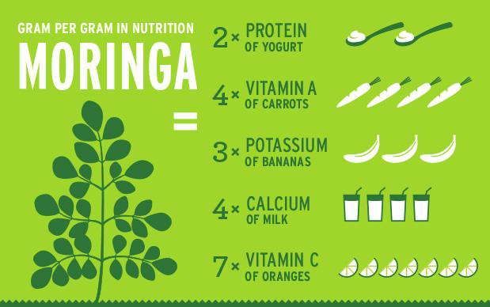

Figure 3: Moringa A “SUPER FOOD”

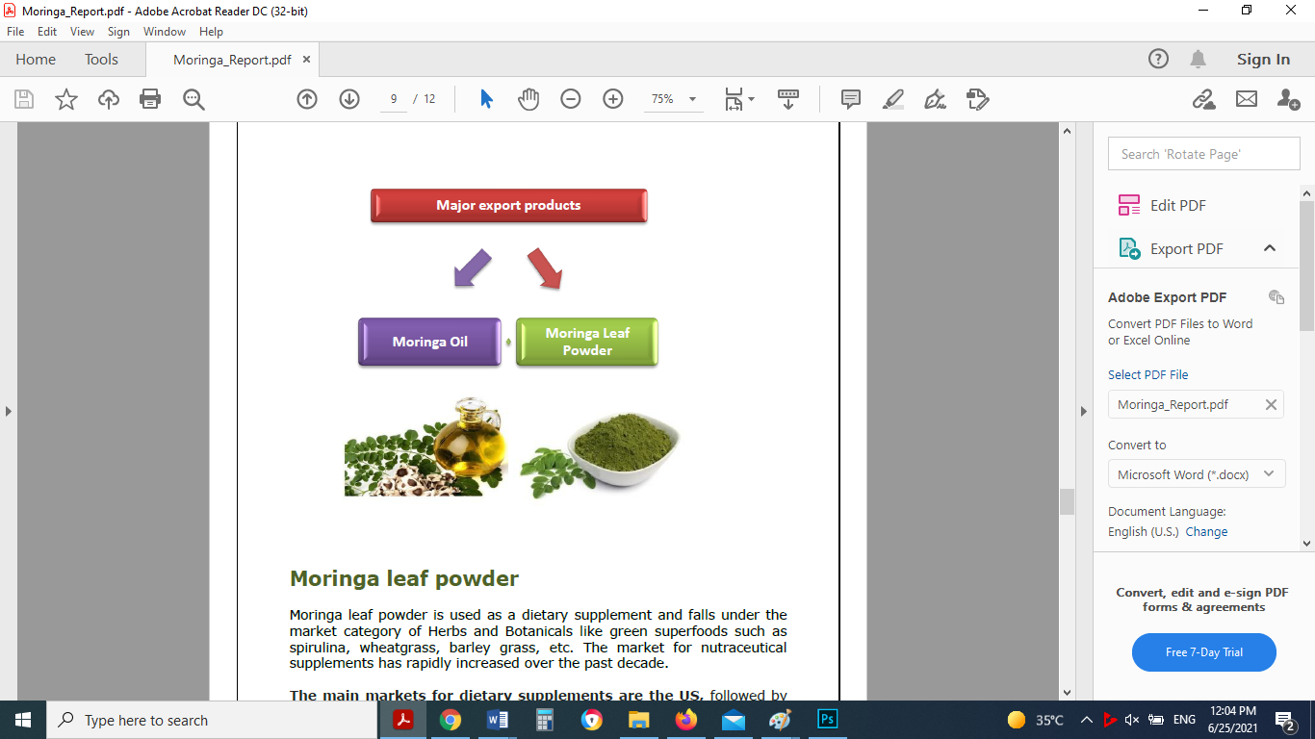

Figure 4: Moringa major products

**Moringa leaf powder**

Moringa leaf powder is used as a dietary supplement and falls under the market category of Herbs and Botanicals like green superfoods such as spirulina, wheatgrass, barley grass, etc. The market for nutraceutical supplements has rapidly increased over the past decade. The main markets for dietary supplements are the US, followed by Western Europe and Japan, all with an affluent middle class willing to invest in alternative health and food products. US dominate the overall market in nutritional supplements, Europe accounts for the largest share of the world market in herbal/botanical supplements and remedies. Asia-Pacific and Japan make up the other important market for botanicals, with the Asia-Pacific market (led largely by China and India) set to pave the way with the highest growth rate (10.5%) through 2017 (Global Industry Analysts, Inc, 2013). Judging by the increasing number of products available on the international market it seems safe to say that demand for moringa leaf powder products is growing.

In the US, moringa is increasingly becoming available in health shops, both online and offline. While the leaf powder has been sold for a few years already and products like health bars, and dietary supplement used in teas or energy drinks. They are marketed as caffeine free energy boosters and as a superfood, with a composition comparable to spirulina. Under EU regulation, only the whole or powdered leaves of moringa are allowed to be imported as food. India dominates the current global market and meets more than 80% of global demand. That such a large percentage of global moringa production is taking place in India is largely due to the long tradition of including moringa in its food consumption. As a result, Indian moringa is grown on large plantations, making it possible for Indian wholesalers to sell moringa leaf powder at a comparatively low price (and most of the time online). Many companies are coming up with claims that their moringa leaf powder is, as a result, of a higher quality, while also providing a story that Western consumers consider important. Moringa leaves need to be dried immediately upon harvesting and the cost of transporting loose dried leaves is high which means EU buyers are dependent on countries that produce moringa in powdered form in order to meet their demands. Indian wholesalers offer moringa leaf powder at a comparatively low price. Pricing of Moringa Leaf Powder on the International Market depend on quantity, quality, and end use of the product. Wholesale prices for Indian moringa leaf powder (the product sold on the largest scale) range from US$ 2.26 - 7.90/lb, with an average price of US$ 2.97/lb. (source: ZAUBA.com).

**Moringa Oil**

Exotic plant-based oils like moringa often have specific active and functional properties, making them particularly valuable for use in cosmetic products. Following health and wellness trends, Western consumers increasingly prefer cosmetics with ingredients derived from plants, rather than mineral oil. This trend-—to consume 'truly natural’ cosmetic products—is in line with other patterns in eastern society, where consumers increasingly adopt green values and seek out companies that accept responsibility for social issues and the environment. In response to these trends, the cosmetic industry has begun to differentiate its products by using more exotic vegetable oils, in turn triggering a growing international demand (and thus higher prices) for oils derived from sources like moringa.

Global trade statistics are only available in an aggregated form for exotic vegetable oils. Besides moringa oil, which constitutes a minor proportion, this product group also includes apricot kernel oil, cupuacu butter, argan oil, baobab, papaya seed oil, sheabutter and others. Moreover, the data does not allow for distinguishing between fully natural products and chemically refined products (CBI, 2009).It deals with analyzing the general market trends for exotic vegetable oils, which includes moringa oil. The volume of global imports of exotic vegetable oils was at a high level in 2007 (approximately 700,000 tons) and maintained a quite constant level during 2010 and 2011 (approximately 600,000 tons).The single most important importer was the EU, which imported around half of the volume from Developing Countries (DCs). The value of global imports of exotic vegetable oils increased from around US$ 1.05 billion in 2009 to almost US$ 1.4 billion in 2011. This shows that exotic vegetable oils are an increasingly attractive high value-added commodity. According to the trade statistics website Zauba.com, wholesale prices for moringa oil exported from India ranged from US$4.05 - 16.70/lb over the period 2012 - 2014, with an average price of US$10.31/lb. In liters, this translated to an average price of US $32.13/L (minimum US$18.5/L, maximum US $79.64/L). Producers of moringa oil in various other DCs reported they were able to get around US $15.45/lb for their moringa oil (sourced from local smallholder farmers) on the international market (source: Moringa Connect).

## Moringa local market

Some farmers planted the moringa tree in Palestine in separate areas in the West Bank and Gaza Strip, but in small quantities and there are no official or known statistics about the quantities that have been planted, as these projects are considered experimental projects.

The farmers market moringa products such as ground leaves, moringa capsules and moringa oil in the West Bank and Gaza Strip, but in herbalist shops and some pharmacies.

The local marketing of Moringa products needs a great effort in introducing consumers to the importance of Moringa and its products and its nutritional and medicinal benefits.

## Herbs Global Market

According to global market studies in herbs industry such as Herbal Supplements Market[[15]](#footnote-15), the  herbal supplements market, in terms of value, is projected to reach around USD 86.74 Billion by 2022, at a CAGR of 6.8% from 2016 to 2022. The growing awareness for preventive healthcare methods is the major driving factor of this market, while according to Herbal Medicine Market Global Sales[[16]](#footnote-16), the global herbal medicine market size was estimated to be US$ 83 billion in 2019 and is expected to reach US$ 550 billion by 2030 at a CAGR 18.9% through 2030. An herb is basically a plant or plant part that is used in medicine, because of its scent, flavor, or its therapeutic properties. Herbal medicines are a type of dietary supplement. They make use of plants or plant parts, to treat disease and enhance general health and wellbeing.

The global market based on sources has been segmented into leaves, barks, fruits & vegetables, and roots. The leaves segment accounted for the largest market share in 2015 as herbal supplements are largely made up of plant leaves. Leaves of herbal plants contain medicinal properties, which are extracted for the production of herbal supplements. Ginkgo biloba and Camellia sinuses (green tea) are some of the common leaf extracts used to make these supplements. The demand for herbal products in medicines, food & beverage, and cosmetics has led to the growth of the leaves segment in the market.

The global market, based on application, has been segmented into pharmaceuticals, food & beverages, and personal care. The pharmaceuticals segment accounted for the largest share of the herbal supplements market in 2015. The Latin American and Asia-Pacific regions are potential markets for herbal supplements in the pharmaceutical industry due to increased efficiency in research & development initiatives taken by manufacturers, as well as consumer preference toward herbal medications. The Asia-Pacific region is also expected to grow in the herbal drug market since consumers are demanding alternative medicinal products such as traditional Chinese and ayurvedic treatments.

On the basis of form, the herbal supplements market is segmented by capsules & tablets, powder, syrups, and oils. The capsules & tablets segment dominated the market. Consumers’ preference towards capsules & tablets due to its ease in consumption has led to its growth in the market. Moreover, high growth of the pharmaceutical industry in the developing countries, such as India and China have led to the demand for capsules & tablets in the herbal supplements industry

**Europe leads the Herbal Medicine Market, Asia Pacific market growing fast**

Europe dominated the global herbal medicine market and is expected to retain the lead position throughout the forecast period as well. Trustworthy sources, such as associations including the likes of the British Herbal Medicine Association and the European Herbal and Traditional Medicine Practitioners Association (EHTPA), routinely promote the usage of these natural medicines in the European region, by the organisation of various seminars, and spread awareness regarding the benefits of using herbal alternatives.

Asia Pacific is expected to show the fastest growth over the foreseen period due to increasing awareness about these medicines which include drugs, dietary supplements, and skin care products. The countries of India and China are the major markets for herbal medicinal products in the Asia Pacific region.

## Herbs Local Market

Since ancient times, the people of Palestine have used a wide list of plants in human and veterinary medicine; Including: Thyme: It is used as food and as a treatment for respiratory diseases; Al-Jada: It is used to treat diabetes and to treat colic; Clay: It has been used to treat wounds and fractures; Artemisia: It has been used to treat diseases of the urinary system and colic; Chamomile: It was used as a soothing drink; And sage: It has been used to get rid of colic and colds; Peppermint: used as a sedative; Harmal: It was used to arouse male and female sheep; Capers: It is used to treat joints; The people of Palestine also traded these plants with neighboring countries and regions in the Levant, Egypt and Iraq.

Today, many citizens have tended to grow these plants for commercial use. Among the most important governorates that are famous for the cultivation of medicinal plants today in Palestine[[17]](#footnote-17) are:

**Tubas Governorate**

The total area in it is about 790 dunums distributed as in the following table:

| # | Region | The area in acres (dunums) | |
| --- | --- | --- | --- |
| Protected/ irrigated | Exposed/ irrigated |
| 1 | Ras Al Fara'a | 250 | 50 |
| 2 | Qeshda | 75 | 50 |
| 3 | Tamon | 80 | 35 |
| 4 | Al-Baqia | 0 | 130 |
| 5 | Bradala | 30 |  |
| 6 | Ain al-Bayda | 25 |  |
| 7 | Valley of the Fara | 25 |  |
| 8 | Sahel Tubas | 20 |  |
|  | Sum | 490 | 300 |

Among the most important varieties and types of medicinal plants cultivated in Tubas Governorate are Mint, Rosemary, Lemon thyme, Rocolla, Sorrel, Marjoram, thyme, chives, Tarragon, Melissa, F.parsely, Pepper mint, Red Sorrel, Lemon Basil, Sacura, Pea shoots, Oregano Basil, Savory, Sage.

The quantity produced from medicinal plants in Tubas Governorate in 2016 was about 2,000 tons, of which about 750 tons were exported to the foreign market, and 350 tons were exported to Israel; While there are about 800 tons unfit for export.

Difficulties and obstacles facing the cultivation of medicinal plants in Tubas Governorate:

1. Monopolizing the production and marketing of these products by some traders
2. The incompatibility of these products with the wishes of the local consumer; which makes it dependent only on the external market.
3. Return of some marketed quantities; on the grounds that it does not conform to the specifications.
4. The high prices of these products due to the high production costs.
5. The needs of these products for irrigation water are high.
6. Due to the sensitivity of this product, it needs special treatments and equipment.

**Jenin Governorate**

Medicinal plants are cultivated in the governorate according to two patterns:

Protected cultivation, concentrated in Sir and Jdeideh.

Open cultivation, concentrated in the Maythaloun area and some small areas in the Jenin Plain.

The areas planted with medicinal plants in the Jenin governorate are estimated at about 86 dunams planted in protected cultivation within greenhouses in the form of high tunnels, and about 130 dunams under irrigated open cultivation; In addition to about 300 dunums of wild thyme scattered in all regions of the governorate.

The production rate in Jenin governorate for medicinal plants is an average of 6 cuts per season, at a rate of about 400 kg per dunum of green crop, and wild thyme is cut 3 shear per season at a rate of 150 kg of dry thyme per cut.

Among the most important varieties and types of medicinal plants cultivated in Jenin Governorate are Mint, Rosemary, Rocolla, , Marjoram, thyme, chives, Tarragon, Oregano, Basil, Red basil.

Among the most important obstacles facing the cultivation of medicinal plants in Jenin governorate are:

1. Water scarcity in the area.
2. Export restrictions and conditions imposed by importing countries.

**Jericho and the Jordan Valley**

The area planted for medicinal plants in the Jericho and the Jordan Valley in 2017 was estimated to be about 300 dunums; The total production rate of the governorate is about 39 tons for the year 2017.

The following table shows the types cultivated in the governorate, the distribution of the area for each variety, and the production rate of the dunum (tons).

| # | Varity | Cultivated area (Dunum) | Dunum production rate (tons) |
| --- | --- | --- | --- |
| 1 | Mint | 26 | 3 |
| 2 | Rosemary | 22 | 3 |
| 3 | Lemon thyme | 1 | 2.5 |
| 4 | Rocolla | 15 | 2 |
| 5 | Marijoram | 3 | 2.5 |
| 6 | Thyme | 8 | 2.5 |
| 7 | Chives | 24 | 3 |
| 8 | Coriander | 10 | 3.5 |
| 9 | F.parsely | 15 | 4 |
| 10 | Oregano | 3 | 2.5 |
| 11 | Basil | 120 | 2 |
| 12 | Sage | 9 | 3 |
| 13 | Dill | 10 | 3.5 |
| 14 | Redbasil | 34 | 2 |
|  | Total |  |  |

Production in the Jericho Governorate of medicinal plants is limited to local consumption, without export.

The obstacles facing the cultivation of medicinal plants in the governorate of Jericho and the Jordan Valley, they are:

1. The lack of sufficient irrigation quantities due to the Israeli control over the water resources and the control of drilling and rehabilitation of underground wells and the climatic changes facing the region.
2. Israeli control over the crossings and borders, as the occupation intends to obstruct the export of the product.
3. Difficulty accessing Israeli markets.
4. Lack of technical expertise in this field.
5. Lack of good quality fertilizers due to the Israeli security ban.

**Tulkarm Governorate**

Several types of medicinal plants are grown in the lands of Tulkarm Governorate, the most prominent of which are:

1. Thyme

**-**Thyme constitutes the largest share of the medicinal plants cultivated in the governorate. Where the cultivated area reaches 1000 dunums; A total of 12,000 thyme seedlings are planted in one dunum, and the cultivated areas are: Khirbet Jbara, Faraoun, Kafr Jamal, Shweika, Nazla Al Sharqiah, Baqa Al Sharqiah, Zita and Ateel. The cultivated varieties:

* + Wild thyme: It is cultivated as irrigated. It bears thirst conditions and multiplies with seeds.
  + Thyme cultivar: irrigated only; Where it does not stand thirst, and is characterized by its strong vegetative growth, the large size of the leaves and the shape of the leaf is circular, and it is abundant with the Cuttings.
  + The productivity of an acre of irrigated green thyme reaches 5 tons per year, while the dryer is 850 kg. Most of the production is consumed locally, either green or dried. It is also exported to Jordan, where the export in 2016 was 39 tons, in addition to 48 tons to the Gaza Strip.

1. Sagebrush: Sagebrush is grown in small quantities and areas in the governorate, the total area does not exceed 20 dunums, and it is concentrated in: Beit Lid, Kafr Abush, and Kafr Zibad. Most of this area is rain-fed, and its production quantities are small, as a dunum is produced up to 120 kilos of dryer and is marketed locally.
2. Lavender: This variety was planted in 2017 in Deir Al-Ghosoun, with an area of five dunums.

**Qalqilya Governorate**

In Qalqilya governorate, thyme is the only commercially grown variety; The cultivated area is 1,100 dunums irrigated, and 200 dunums rain-fed. It is grown in the city of Qalqilya, Jayyous, Falamiya, Azzun Atma, and Jinsafut.

Among the types of thyme in the governorate are Baladi, Turkish, and D4. The production is distributed between the local market (about 954 tons) and export (about 146.5 tons in 2016 and 116.2 tons until April/2017). Among the countries importing thyme, Jordan.

Among the obstacles facing the cultivation of thyme in Qalqilya:

1. Price fluctuations
2. External marketing.

**Nablus Governorate**

In the Nablus governorate, thyme is grown in: Al-Aqrabaniya and Al-Nasaria (the central Jordan Valley), on about 350 dunums, producing 1200 tons of thyme. 40% of the production goes to the local market and 60% for export.

Among the obstacles facing the cultivation of thyme in the Nablus governorate are low prices; this makes the cost higher than the return for the farmer; after thyme was grown on 1,000 dunums, it shrank in 2016 to reach 350 dunums.

**Hebron Governorate**

Cultivated in the Hebron Governorate: sage, mint, thyme, and chamomile. The following table shows the distribution of that cultivation by regions, the cultivated area and the quantity of production:

| # | Varity | Region | Cultivated area (Dunum) | Dunum production rate (kg) |
| --- | --- | --- | --- | --- |
| 1 | sage | Western and Central Line | 22 | 1300 |
| 2 | Mint | Western line & Coziba | 24 | 3000 |
| 3 | Thyme | Western and Central Line | 50 | 1100 |
| 4 | chamomile | Sa'ir & the Sheyukh | 5 | 500 |

**Dura, south of Hebron Governorate**

The town of Dura is interested in cultivating:

1. Mint: the cultivated area is estimated at about 13 dunums; Its production is estimated to be approximately 20 tons of green mint.
2. Watercress: the cultivated area is estimated at 3 dunums; Its productivity is about 2 tons; It is grown in winter in the Dura region.
3. Sage, thyme and cornea: They are grown in home farming, and are for home consumption only. It is distributed on all sites of the Directorate of Agriculture Dura.

The needs of the region: The needs of medicinal and aromatic plants in the sites of the Dura Agriculture Directorate are estimated at approximately 100 tons; So there is no export; As the quantity consumed exceeds the product, and there is no room for export.

Among the obstacles facing the cultivation of medicinal plants in Dura

1. The amount of water is not enough
2. Price fluctuations
3. The low amount of rain, and its irregular distribution in the region.
4. Lack of marketing companies.

**Yatta town**

It is cultivated in the town of Yatta, on an area of ​​about 19 dunums, with a production rate of 8400 kg/rain and 9000 kg/irrigated; and mint on an area of ​​3 dunums, with a production rate of 7000 kg/irrigated, and there is no rained cultivation of mint in Yatta; As for thyme, it is grown on an area of ​​5 dunums, with a production rate of 500 kg/ rain, and 7000 kg is irrigated.

It is cultivated in Umm al-Khair sagebrush on an area of ​​1 dunum, with a production rate of 400 kg/ rain, and there is no irrigated sage cultivation in Umm al-Khair; As for thyme, it is grown on an area of ​​2 dunums, with a production rate of 3000 kg/irrigated. There is no rained cultivation in Umm al-Khair for thyme.

In Al-Samo`, sage is grown on an area of ​​2 dunums, with a production rate of 500 kg/ rain, and 1600 kg/irrigated; Mint is planted on an area of ​​1 dunum with a production rate of 2000 kg/irrigated. There is no cultivation of rain cultivated mint in Samu'; Also, thyme is planted on an area of ​​1 dunum, with a production rate of 1500 kg/irrigated. There is no cultivation of Baal thyme in Al-Samou.

They are distributed as in the following table:

|  |  |  |  |  |  |  |  |  |  |  |
| --- | --- | --- | --- | --- | --- | --- | --- | --- | --- | --- |
| Assembly name | Sage | | | | Mint | | Thyme | | | |
| The area dunum /rain | Productivity /kg | The area dunum /irrigated | Productivity /kg | The area dunum /irrigated | Productivity /kg | The area dunum /rain | Productivity /kg | The area dunum /irrigated | Productivity /kg |
| Yatta | 4 | 8400 | 5 | 9000 | 3 | 7000 | 1 | 500 | 4 | 7000 |
| Um Khair | 1 | 400 | 0 | 0 | 0 | 0 | 0 | 0 | 2 | 3000 |
| Al-Samo` | 1 | 500 | 1 | 1600 | 1 | 2000 | 0 | 0 | 1 | 1500 |
| Total | 16 | 9300 | 6 | 10600 | 4 | 9000 | 1 | 500 | 7 | 11500 |

Obstacles to the cultivation of medicinal plants in Yatta are:

1. Lack of water.
2. Lack of experience in manufacturing and packaging.
3. Difficulty in marketing due to closures and lack of export.
4. The lack of factories to manufacture the surplus in the summer.
5. Lack of sufficient experience in manufacturing oils and perfumes.
6. Lack of experience in producing larger quantities.

Among the most important countries importing medicinal plants from Palestine are:

1. United States of America
2. United Arab Emirates (UAE)
3. Russia
4. Europe Union

## Expected Market and Competition

Melia Co. will market its product initially in local market, and later in external markets. As shown in market studies, the potential markets are in the following points:

[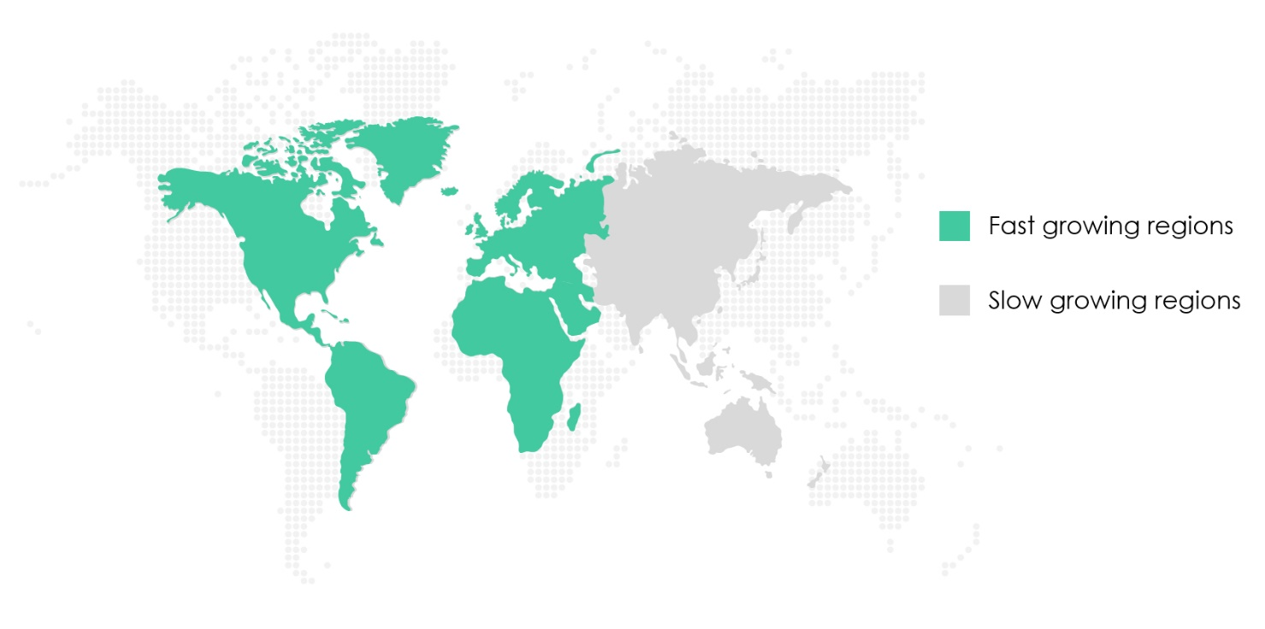](https://www.technavio.com/talk-to-us?report=IRTNTR40112&type=sample&src=)

Figure 5: Moringa Products Market: Segmentation by Geography[[18]](#footnote-18)

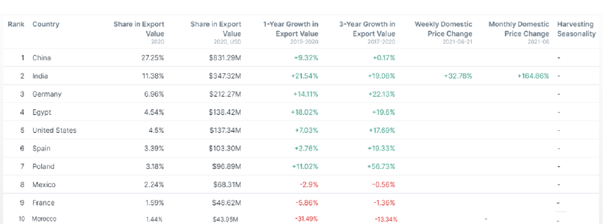

Figure 6 Overview of Global Moringa Market**[[19]](#footnote-19)**

1- Moringa products; the potential markets are:

**EU Countries and UK**

* Demand for moringa is increasing in the European market. It has a range of health benefits that makes it appealing to European consumers who are looking for natural health products to improve their health and well-being. Demand for moringa in nutritional supplements is increasing because of an ageing population, rising veganism and vegetarianism, growing need to reduce calories and weight loss. These factors are expected to increase the use of moringa in nutritional supplements. However, demand is hindered by relatively low consumer awareness of moringa products in Europe.
* In European markets, the main competitors are big and medium Indian companies. India[[20]](#footnote-20) is the leading producer of moringa drumsticks in the wold with a production of 2.2 million tons of tender fruits annually, according to Agri Exchange. The production area is around 43,600 hectares; the main producing states include Andhra Pradesh, Tamil Nadu and Karnataka. In India, most moringa is produced on large plantations. The cultivation of moringa varies between different parts of India. In the Northern and Eastern parts, leaves are harvested in December and January. In the Southern parts, the peak season for harvesting is between July/September and March/April.
* Moringa is also produced in Asia, Africa and Latin America in countries such as the Philippines and Bangladesh, Pakistan, South Africa, Ghana, Mozambique, Kenya, Zambia, Pakistan, Brazil and Peru.
* The prices of Moringa products

| Product | Price of 1 kg (USD) | | |
| --- | --- | --- | --- |
| India | Pakistan | China |
| [Dried Moringa Leaves](https://www.indiamart.com/proddetail/dried-moringa-leaves-8613480097.html) | 3.7 -4.0 | 6.30- 7.60 | 12.50-16.20 |
| [Moringa Leaves](https://www.indiamart.com/proddetail/dried-moringa-leaves-8613480097.html) powder | 6.80 | 9.82 -12 | 17.30-19.20 |
| Moringa seeds | 8.08 -16.0 | 18.40-20.00 | 8.00-15.00 |
| Moringa seed powder | 13.50 - 21.6 | 12.66-14.20 | 30.00-45.00 |
| Moringa oil | 21.6 - 32.40 | 23.43 | 35.00-40.00 |
| Moringa honey | 8.085 - 10.80 | 8.87 -9.40 | 5.50-7.50 |
| Herbal Moringa capsules (100 capsules) | 6.80-7 | 4.43- 6.33 | 3.00-5.00 |

* There is a growing market for nutritional supplements in Europe. According to the [Fortune Business Insights](https://www.globenewswire.com/news-release/2020/01/09/1968257/0/en/Europe-Dietary-Supplements-Market-Size-to-Reach-USD-20-89-Billion-by-2026-High-Demand-for-Clean-label-Products-to-Boost-Growth-Fortune-Business-Insights.html), the European dietary supplements market is projected to reach USD 20.9 billion by 2026. It is forecast that the market will grow at a compound annual growth rate of 4.9 percent between 2019 and 2026.
* Despite relatively low consumer awareness of moringa, the market is growing. According to [Reportlinker](https://www.globenewswire.com/news-release/2020/04/23/2020686/0/en/Europe-Moringa-Products-Market-to-2027-Regional-Analysis-and-Forecasts-by-Product-Application-and-Country.html" \t "_blank), the European moringa products market was valued at USD 903 million in 2018. It is forecast that the market will grow at a compound annual growth rate of 8.7 percent to reach USD 1.9 billion by 2027. The main driver is growing awareness of moringa’s health properties, such as stress reduction, immunity boosting and anti-diabetic.
* Moringa also helps boost personal immunity. In Europe, there is growing demand for health products that promote the immune system. According to [Wellmune consumer research](https://www.wellmune.com/2019/12/11/immune-support-is-most-sought-health-goal-global-survey-finds/" \t "_blank), around 42 percent of global consumers look for products that can improve their health. About 20 percent said that immune support was their number one reason for purchasing healthy lifestyle products. The COVID-19 pandemic has further increased demand for immune-boosting health products.
* According to industry sources, this trend will become more important for European consumers. Rising health consciousness and increasing disposable income are also driving the demand for health products in Europe.
* Prices of Moringa products in Germany and Franc as samples of EU countries

|  |  |  |
| --- | --- | --- |
| Product | Price of 1 kg (USD) | |
| Germany | France |
| [Dried Moringa Leaves](https://www.indiamart.com/proddetail/dried-moringa-leaves-8613480097.html) | 53.71- 83.55 | 62.69 |
| [Moringa Leaves](https://www.indiamart.com/proddetail/dried-moringa-leaves-8613480097.html) powder | 38.20- 57.29 | 68.75 |
| Organic Moringa Leaf Powder | 107.42 | 119.36- 143.23 |
| Moringa seeds | 107.42-163.52 |  |
| Moringa oil | 190.98- 208.88 | 189 |
| Herbal Moringa capsules (100 capsules) | 14.32- 15.28 |  |
| [Organic Moringa Capsules](https://www.amazon.de/-/en/Organic-Moringa-Capsules-Laboratory-Ingredients/dp/B010BW5P10/ref=pd_lpo_121_t_0/262-2796707-4751248?_encoding=UTF8&pd_rd_i=B010BW5P10&pd_rd_r=4413c015-2a93-4b5d-aaf7-adf6301e2505&pd_rd_w=OrUs7&pd_rd_wg=nW4HT&pf_rd_p=09ea9b56-9040-40db-aab6-4478ca27bcd8&pf_rd_r=FN5FYAM8XFB2XG7EXMV8&psc=1&refRID=FN5FYAM8XFB2XG7EXMV8) (100 capsules) | 16.71- 20.29 |  |

**Note that organic product price is 125% to 224.9 %of conventional products**

* Melia can market Moring leaves, powder, Moringa pages, and Moringa oil, in either conventional or organic production. For the first 3 years of this project, Melia will market as conventional or conversion to organic due to technical in organic rules of EU commission, but it is preferred to start registering in organic production certification (EU organic production) because of profitability and marketability of organic Moringa, i.e the price of organic Moringa is twice price of conventional Moringa. Besides, to organic certification, Melia can starts Global GAP certification.

**North America, USA, and Canada[[21]](#footnote-21)**

* The North American market for moringa products was valued at US$ 1062.2 million in 2018 and is expected to grow at a CAGR of 8.8% during 2019-2027 to reach US$ 2248.2 million by 2027.
* Moringa is loaded with essential nutrients such as protein, fiber, phosphorous, fat, carbohydrates, and potassium. Owing to such attributes, moringa is widely used to cure anemia, cancer, diarrhea, headache arthritis, asthma, diabetes, and other health problems.
* The leaves and pods of Moringa are commonly eaten in parts of North America. In Western countries, the dried leaves are usually sold as dietary supplements, in either capsule or powdered form. The pods have lower mineral and vitamin content than the leaves; however, they are rich in vitamin C.
* Moringa products serve to be a vital source of many essential nutrients and antioxidants. Ancient Egyptians used the oil extracted from moringa as a potent cure for skin disorders. Moringa oil is rich in essential fatty acids, which make it an ideal moisturizing agent as well as healing and soothing emollient for dry, rough skin; it thus can also be used in therapeutic massages. However, it is unsafe to expose pregnant women to the bark or roots of moringa. Chemicals in the bark, root, and flowers make the uterus contract, and this can possibly lead to miscarriages. There is no sufficient information available about the safety of consuming other parts of moringa during pregnancy.
* The North American market for moringa products is still underdeveloped. Only an acute portion of North American consumers knows about moringa and its attributed advantages. Therefore, awareness regarding the advantages and benefits of moringa is necessary among a significantly large portion of the population in the region. With increasing health-consciousness among the consumers, the demand for moringa products in the region is expected to continue to grow over the forecast period. Moringa oleifera is known as a miracle plant with enormous potentials as it is yet to be fully explored in the food application. The use of moringa leaf powder, moringa seed powder, moringa flower powder in various food applications such as in fortifying ogi (maize gruel), amala (stiff dough), bread, yogurt, cheese, biscuits, and soup preparations has been known these days.
* Moringa Malawi, Kuli Kuli Inc., Organic India Pvt. Ltd., Ancient Greenfields, Green Virgin Products LLC, and Earth Expo Company are among a few players present in the North American moringa products market.
* The overall North American moringa products market size has been derived using both primary and secondary sources. The research process begins with exhaustive secondary research using internal and external sources to obtain qualitative and quantitative information related to the North America Moringa Products market.
* Reasons to Buy:
* Highlights key business priorities in order to assist companies to realign their business strategies.
* The key findings and recommendations highlight crucial progressive industry trends in the North America Moringa Product market, thereby allowing players to develop effective long term strategies.
* Develop/modify business expansion plans by using substantial growth offering developed and emerging markets.
* Scrutinize in-depth the market trends and outlook coupled with the factors driving the market, as well as those hindering it.
* Enhance the decision-making process by understanding the strategies that underpin commercial interest with respect to products, segmentation and industry verticals.

**Arabic Countries**

**Egypt**

* Egypt shares 4.54% export globally, and it is ranked fourth country in the world. The export value of Egypt was USD 138.42 Million in 2020.

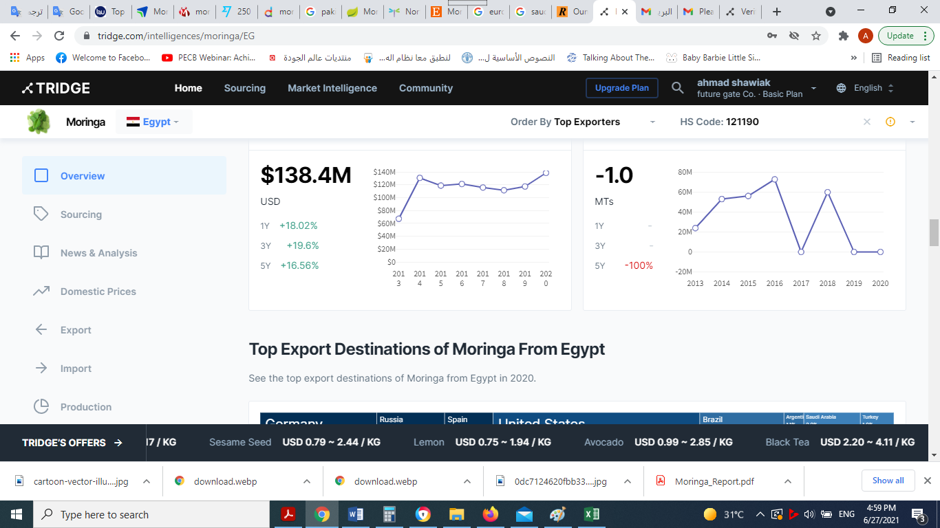

Figure 6 Overview of Moringa Exports from Egypt

**Morocco**

* Morocco shares 4.54% export globally, and it is ranked tenth country in the world. The export value of Morocco was USD 43.95 Million, in 2020

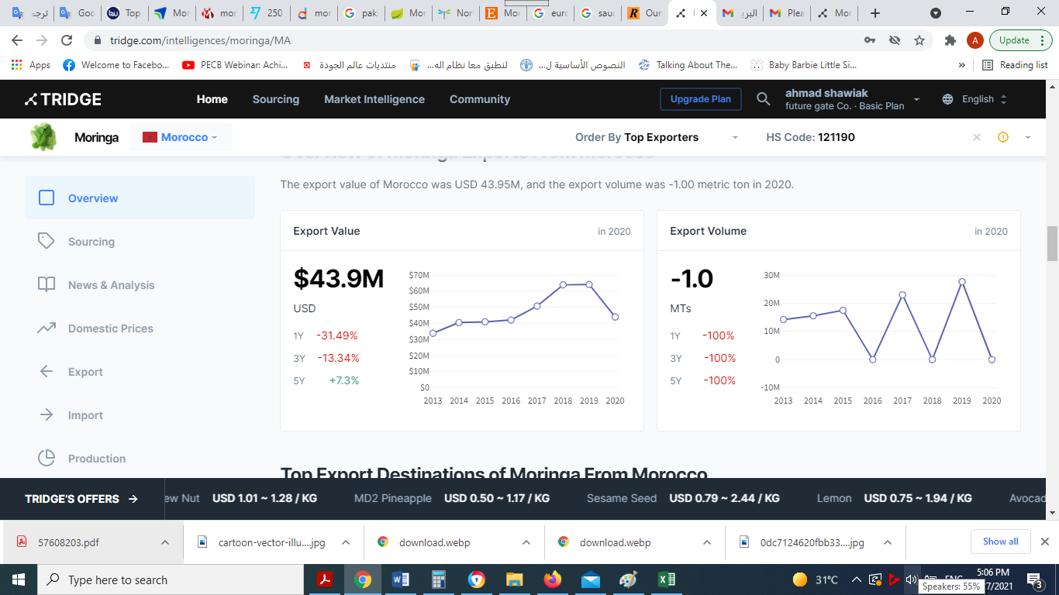

Figure **7**: Overview of Moringa Exports From Morocco

**Arabic gulf countries**

* Some farmers planted Moringa especially in Arabia Saudi, but the quantities of produced Moringa are not significant.
* These countries import Moringa from India mainly (USD 4 /kg paper moringa, USD 25/ Kg oil).
* Moringa products are consumed in these countries, and consumers are aware of its benefits in medical and nutrition.
* Prices of Moringa products in Arabic, and the following tables shows prices in selected countries.

|  |  |  |  |  |  |
| --- | --- | --- | --- | --- | --- |
| Product | Price of 1 kg (USD) | | | | |
| Arabia Saudi | Emirates | Egypt | Algeria | Morocco |
| [Dried Moringa Leaves](https://www.indiamart.com/proddetail/dried-moringa-leaves-8613480097.html) |  |  | 15.94 | 11.19 | 41.60 |
| [Moringa Leaves](https://www.indiamart.com/proddetail/dried-moringa-leaves-8613480097.html) powder | 96.00 | 61.25- 74.87 | 19.13 | 10.07 | 51.72 |
| Organic  [Moringa Leaves](https://www.indiamart.com/proddetail/dried-moringa-leaves-8613480097.html) powder | 176.00 | 88.48 |  |  |  |
| Moringa seeds |  |  | 28.69 |  | 28.11 |
| Moringa seeds powder |  |  | 44.64 |  |  |
| Moringa oil | 397.60- 517.34 | 163.35- 179.68 | 52.29- 59.30 |  |  |
| Herbal Moringa capsules (100 capsules) | 39.20 | 12.25 |  | 13.42 | 0.63 |

1. Market Intelligence Report: Moringa, Agri Exchange: Indian Trade portal , <https://agriexchange.apeda.gov.in>,2018. [↑](#footnote-ref-1)
2. (CAGR) is the [rate of return](https://www.investopedia.com/terms/r/rateofreturn.asp) that would be required for an investment to grow from its beginning balance to its ending balance, assuming the profits were reinvested at the end of each year of the investment’s life span. [↑](#footnote-ref-2)
3. Herbal Supplements Market by Source (Leaves, Barks, Fruits & Vegetables, and Roots), Application (Pharmaceuticals, Food & Beverage, and Personal Care), Function (Medicinal and Aroma), Form, and Region - Global Forecast to 2022, https://www.marketsandmarkets.com/Market-Reports/herbal-supplements-market-736.html [↑](#footnote-ref-3)
4. Herbal Medicine Market Global Sales Are Expected To Reach US$ 550 Billion by 2030, as stated by insight SLICE, https://www.globenewswire.com [↑](#footnote-ref-4)
5. https://www.aa.com.tr/ar [↑](#footnote-ref-5)
6. https://info.wafa.ps/ar\_page.aspx?id=20027 [↑](#footnote-ref-6)
7. www.cbi.eu/market-information/natural-ingredients-health-products/moringa/market-potential [↑](#footnote-ref-7)
8. https://foodstrend.com/moringa-plant-10-miraculous-benefits [↑](#footnote-ref-8)
9. https://www.exportgenius.in/ersag-end%C3%9Cstriyel-ve-kimyasal-temizlik-%C3%9Cr%C3%9Cnleri-pazarlama-turizm-gida-saat-sanayi-ticaret-limited-sirketi-exporter-in-turkey,[info@exportgenius.in](mailto:info@exportgenius.in) [↑](#footnote-ref-9)
10. Every 1000 m2 produces net moringa leaves 224 kg/1000 m2/ year, seeds 150 kg/ 1000 m2, extraction ratio is 0.125 kg oil/ 1 kg seeds. [↑](#footnote-ref-10)
11. https://www.thespruce.com/how-to-grow-and-care-for-moringa-plants-5076022 [↑](#footnote-ref-11)
12. Every 1000 m2 produces net moringa leaves 224 kg/1000 m2/ year, seeds 150 kg/ 1000 m2, extraction ratio is 0.125 kg oil/ 1 kg seeds i.e . 8.75 Kg oil /1000 m2 [↑](#footnote-ref-12)
13. Market Intelligence Report: Moringa, Agri Exchange: Indian Trade portal , <https://agriexchange.apeda.gov.in>,2018. [↑](#footnote-ref-13)
14. (CAGR) is the [rate of return](https://www.investopedia.com/terms/r/rateofreturn.asp) that would be required for an investment to grow from its beginning balance to its ending balance, assuming the profits were reinvested at the end of each year of the investment’s life span. [↑](#footnote-ref-14)
15. Herbal Supplements Market by Source (Leaves, Barks, Fruits & Vegetables, and Roots), Application (Pharmaceuticals, Food & Beverage, and Personal Care), Function (Medicinal and Aroma), Form, and Region - Global Forecast to 2022, https://www.marketsandmarkets.com/Market-Reports/herbal-supplements-market-736.html [↑](#footnote-ref-15)
16. Herbal Medicine Market Global Sales Are Expected To Reach US$ 550 Billion by 2030, as stated by insight SLICE, https://www.globenewswire.com [↑](#footnote-ref-16)
17. https://info.wafa.ps/ar\_page.aspx?id=20027 [↑](#footnote-ref-17)
18. Moringa Products Market by Product and Geography - Forecast and Analysis 2021-2025, www.technavio.com/report/moringa-products-market-industry-analysis [↑](#footnote-ref-18)
19. https://www.tridge.com/intelligences/moringa/EG/insights [↑](#footnote-ref-19)
20. www.cbi.eu/market-information/natural-ingredients-health-products/moringa/market-potential [↑](#footnote-ref-20)
21. North America Moringa Products Market (2018 to 2027) - Regional Analysis and Forecasts, https://www.globenewswire.com/news-release/2020/04/24/2021556/0/en/North-America-Moringa-Products-Market-2018-to-2027-Regional-Analysis-and-Forecasts.html [↑](#footnote-ref-21)